**CCDR EEX Methodology Note – Energy Transition Analysis FY24[1],[2]**

**IMPORTANT!**

**This methodology note is a living document. Please make sure you are using the most recent version which can be found on the shared drive at**  [CCDR EEX global resources](https://worldbankgroup.sharepoint.com/:f:/r/teams/decarbenergy-wbgroup/Shared%20Documents/General/03%20CCDRs/CCDR%20EEX%20global%20resources?csf=1&web=1&e=T1JF1n).

1. Introduction 3

1.1 Context 3

1.2 Goal 3

1.3 Audience 3

1.4 Definitions 3

2. Scenarios for analysis 5

3. National Policies in APS World Scenario 6

3.1 National Policies in APS World – demand 7

3.1.1 Demand projections (gross electricity need and peak demand) 7

3.1.2 Load profile 8

3.1.3 Representative days 8

3.2 National Policies in APS World – Supply side technologies 9

3.2.1 List of existing, committed, and candidate plants 9

3.2.2 Cost characteristics of supply side technologies 10

3.2.3 Operational characteristics of supply side technologies 21

3.3 National Policies in APS World – fossil fuel prices 35

3.4 National Policies in APS World – interconnections 35

3.4.1 Internal Interconnections 35

3.4.2 External Interconnections 36

3.5 National Policies in APS World – emission factors 36

3.6 National Policies in APS World – discount rate 37

3.7 National Policies in APS World – WACC 37

3.8 National Policies in APS World – other parameters 38

3.9 National Policies in APS World – Timing parameters 40

4. Power Decarbonization 2050 41

4.1 National Power Decarbonization 2050 in NZE World 41

4.1.1 CAPEX trajectories 41

4.1.2 Fuel prices 45

4.1.3 Demand projections 45

4.2 PD2050-NZEwith electrification of transport (PD2050-NZE-TE) 46

4.3 PD2050-NZE with electrification of heating and cooling services 48

4.4 PD2050-NZE with electrification of industry 51

4.5 PD2050-NZE with Green Hydrogen 51

4.5.1 Green hydrogen production 52

4.5.2 Green hydrogen import 53

4.6 PD2050-NZE scenarios – Timing parameters 54

5. Country-specific scenarios 55

6. Sensitivity analyses 56

7. Outputs 57

8. Scenario comparison and results analysis 60

9. Collaboration with the macrofiscal team 62

10. Additional topics for further analysis in coming FYs 64

11. Annex 1. Additional CAPEX trajectories 65

12. Annex 2. Calculation of economic value of stranded assets. 67

13. Annex 3. Estimation of transmission and distribution costs. 73

14. Annex 4. Timeline. 74

15. Annex 5. Estimation of concessional financing needs. 75

16. Annex 6. End of horizon simulation results. 78

17. Annex 7. Discount rate calculation using WB guidelines. 87

18. Annex 8. Representative days analysis. 88

19. References 97

# Introduction

## Context

This methodology note describes the proposed approach to energy transition analyses for fiscal year 2024 used to inform Country Climate and Development Reports (CCDRs) on the implications of pursuing a low-carbon energy system development pathway and the associated impacts on the electric power sector, i.e., achieving sector development goals while reducing and avoiding greenhouse gas emissions within and through a country’s electric power system. The primary focus of the note is on the electric power system. The note also describes how to model the impact of electrification of other sectors (e.g., transport, buildings, industry, etc.) on the electric power system. Additional guidance on energy sector modelling can be found in the note on Decarbonization Pathways Approaches and Lessons Learnt for ECA countries ([FINAL NOTE Decarbonization Pathways Approaches and Lessons Learnt (ECA).pdf](https://worldbankgroup.sharepoint.com/:b:/r/teams/decarbenergy-wbgroup/Shared%20Documents/General/03%20CCDRs/CCDR%20EEX%20global%20resources/FINAL%20NOTE%20Decarbonization%20Pathways%20Approaches%20and%20Lessons%20Learnt%20(ECA).pdf?csf=1&web=1&e=hFG3BR)).

This Energy Transition Analysis note builds on the [CCDR Energy Transition Analysis FY23 Methodology Note](https://worldbankgroup.sharepoint.com/:w:/r/teams/decarbenergy-wbgroup/Shared%20Documents/General/03%20CCDRs/CCDR%20EEX%20global%20resources/CCDR%20Energy%20Transition%20Analysis%20FY22%20Methodology%20Note.docx?d=wefb847b2a121454384cbf7e384e8d4c9&csf=1&web=1&e=a81Gc5) and the *CCDR EEX approaches note*. Readers are strongly encouraged to familiarize themselves with the content of the *CCDR EEX approaches note* available at [CCDR EEX Approaches Note 2022-04-22.pdf](https://worldbankgroup.sharepoint.com/:b:/r/teams/decarbenergy-wbgroup/Shared%20Documents/General/03%20CCDRs/CCDR%20EEX%20global%20resources/CCDR%20EEX%20Approaches%20Note%202022-04-22.pdf?csf=1&web=1&e=D7inNi).

## Goal

The goal of this reference document is to guide all modelers doing energy transition analyses for the CCDRs, most particularly power system decarbonization modeling, to ensure consistency and (limited) comparability across the analyses completed in the past. This note provides suggestions for all CCDR teams doing energy or power sector modeling regardless of who does the modelling and with which model. At the same time, this document describes how the IEEGK team will use the WB Electricity Planning Model (EPM) for selected countries. The note will inform inputs, outputs, scenario design, and requirements for standardized scenarios for cross-country comparison.

## Audience

The note is intended for internal (WB) and external modelers to perform a detailed energy transition analysis. Other WB task members that review, analyze, or provide inputs to the modelling work may find this note helpful to improve their understanding of power system decarbonization analyses, to facilitate the interpretation of the results, and to improve the development of scenarios.

## Definitions

* CCDR energy team refers to the entire group of people preparing the inputs related to energy for the CCDR. The modelling team, country team and IEEGK team members supporting the analysis for a given country are part of the CCDR energy team.
* Modelling team delineates the part of the task team responsible for running the model underpinning the analysis
* Country energy team refers to the CCDR energy team members mapped to a region. The country energy team leads the analysis.
* Macrofiscal team encompasses people working on the macrofiscal modeling for the CCDR
* The IEEGK team is the global knowledge team. Members of the IEEGK team support the energy transition analysis. The support can be provided by preparing inputs, running the model, supporting the preparation of scenarios, and analyzing results.
* The ESMAP Planning group is a small specialist group within ESMAP (IEEES) that supports planning work within the unit for other thematic areas such as SRMI, markets, cross-supports country teams with planning analyses and develops new analytical methodology and models.

# Scenarios for analysis

Each energy transition analysis for a (group of) country (countries) will include two types of scenarios: harmonized scenarios and country-specific scenarios. There are two harmonized scenarios – *National Policies in APS World* and *National Power Decarbonization 2050 in NZE World -* that are intended to be run near-identically in all analyzed countries for comparison at the global level. A CCDR energy team may additionally run any number of agreed upon country-specific scenarios to explore certain topics of relevance for the country climate-development nexus.

The remainder of this note is organized as follows:

* Section 3 defines the *National Policies in APS World* scenario
* Section 4 defines the *National Power Decarbonization 2050 in NZE World* scenario
* Section 5 defines several common country-specific scenarios that could be considered
* Section 6 introduces possible sensitivity analyses for CCDR energy teams.
* Section 7 introduces a list of required outputs across scenarios
* Section 8 provides initial guidance on scenario comparison and analysis of results
* Section 9 details collaboration between the CCDR energy team and the macrofiscal team
* Section 10 provides an overview of topics for further analysis in upcoming FYs
* Subsequent sections contain detailed annexes and references

# National Policies in APS World Scenario

The *National Policies in APS World* scenariois a harmonized scenario, defined primarily as a common reference scenario for comparison across analyzed countries*. National Policies in APS World* may also serve as the reference scenario for country-specific scenarios unless the country energy team prefers an alternative reference scenario for the purpose of their specific country. *National Policies in APS World* is a least-cost ***economic[3]*** optimization to meet projected demand from the power sector constrained by current national policies that are deemed actionable. When in doubt about the actionability of a policy, the country energy team will be the final arbiter. The spirit of this scenario is to reflect what the country is on track to do, not what the country aspires to do. The purpose of this approach is to show the gap between what is being implemented and what is aligned with a net zero pathway. Current actionable policies should include:

* Impact of past policies (existing and committed generation and transmission assets as a result of historical investments)
* Policies directly actionable, defined as policies that have been translated into a law with a binding target and with clear roles and responsibilities regarding the law implementation (e.g., a law stipulating that the utility needs to meet an RE target by a given target year).[4]

This scenario assumes the rest of the world (ROW) meets its commitments in terms of NDCs and possible long-term net zero emissions targets in full and on time. Therefore, this *National Policies in APS World* scenario assumes a global scenario in line with the “recent commitments and targets & dangerous climate outcomes” as described in the note on [Priority scenarios for CCDR analyses](https://worldbankgroup.sharepoint.com/sites/WBClimate/Knowledge%20Base/Global%20Scenarios%20for%20CCDR%20Analyses.pdf). The selection of that specific ROW future results in dedicated assumptions with respect to long term capital costs (section 3.2.2.2) and fossil fuel prices (section 3.3).

The *National Policies in APS World* scenarioshould include the following characteristics:

1. A recent country specific forecast[5] of required electricity sent out (gross electricity need)[6] from a reputable source either from 1) the entity responsible for power sector planning within the government or the planning department from the main public utility, 2) derived from the WB macro team, or 3) from an experienced consultant (individual or firm)
2. Any ban on the deployment of certain fossil power plants (e.g., coal power plants) from a given future year if the government recently announced such ban and enacted a law to fulfill such obligation
3. Any unconditional NDC targets impacting the power sector (e.g., renewable energy (RE) deployment targets either in terms of capacity (as an absolute amount of capacity deployed in MW or as a relative share in percentage of the total installed capacity) or generation (as an absolute amount of electricity generation in GWh or as a relative share in percentage of the total electricity generation) only if such NDC targets or policies have been translated into a law with a directly responsible entity to adhere to or implement that law
4. Any other legally binding targets the government promised to adhere to in the future that are directly actionable
5. A least-cost generation expansion plan under the above constraints to meet electricity demand while meeting peak power, operational and reserve constraints over a modelling horizon from the initial year 2023 up to 2050

The *National Policies in APS World* scenario will typically not account for climate impacts unless a) the country energy team wants to include climate impacts in this scenario and b) data on the impact of climate change on the electric power system is readily available (e.g., change in hydrological conditions, lower availability of thermal power plants, etc.).

The subsequent sections describe the following inputs for the *National Policies in APS World* scenario: demand, supply side technologies, fuel prices, interconnections, emission factors, discount rate, weighted average cost of capital (WACC), other parameters, and an overview of parameter decisions related to timings.

## National Policies in APS World – demand

The critical inputs in terms of demand for the *National Policies in APS World* scenarioare the gross electricity need and peak demand projections, the projected load profile, and the selected representative days.

### Demand projections (gross electricity need and peak demand)

The starting point for the gross electricity need (in GWh or TWh) projection is a recent forecast from a reputable source. The forecast should contain the split between grid connected demand and off-grid demand for each year of the projections. The CCDR energy team should revise this initial forecast to include any of the following if such measures are part of the government’s current actionable policies and not included in the initial forecast:

* Reductions resulting from the implementation of a recently started or intended technical loss reduction program reducing the level of losses in the transmission and distribution network
* Reductions from the implementation of credible future energy efficiency measures (typically from a country’s energy efficiency and conservation master plan or a national energy efficiency plan from a reputable source)
* Any other recent actionable policies that increase or decrease the projected electricity generation in consultation with the country energy team (e.g., adaptation policies, electric vehicle roll-out targets, etc. n)
* Any impacts of climate change in consultation with the country energy team (e.g., additional electricity needs for desalination, increased demand for heating or cooling services, etc.)

The task team should ensure that the forecast aligns with the GDP growth forecasts from the WB macrofiscal team if the task teams receive such GDP growth forecasts well ahead of the QER. Section 9 details additional interactions between the CCDR energy team and the macrofiscal team.

Yearly peak demand (in MW) should by default be taken from a reputable forecast. Alternatively, the yearly peak demand can be calculated from the projected load factor (LF). Peak demand can then be calculated as gross electricity need divided by 8760 times the load factor. The load factor is preferably projected over the modelling horizon in line with a recent power development plan endorsed by the government. In the absence of any available forecast, the load factor can be taken constant as the average load factor over the past 5 year of available data[7].

CCDR energy teams should verify if the load forecast already incorporates any impacts from the electrification of end-use sectors (e.g., transport, heating and cooling, industry, etc.). This is to ensure that impacts of electrification in the reference transition scenario (*National Policies in APS World*) and other transition scenarios are not double counted.

### Load profile[8]

The load profile projections need to start from a recent load profile (load as a percentage of the peak load) obtained from a recent master plan endorsed by the government, or from the entity responsible for power sector planning within the government or the planning department from the main public utility. The base case does not need to include any change in load profile unless explicitly mentioned by a reputable source.[9]

### Representative days

The model horizon up to 2050 will preferably be split in periods of maximum 2 years[10] each having three time slice levels:

* The first time slice level represents the seasonality of demand over the year and will have at least two periods (e.g., dry and wet season or four quarters).
* The second time slice level represents typical days within the first time slice level
* The third time slice level are the hours within a day. The model needs to have at least 24 time steps (24 hours) within a given representative day

The total number of representative days needs to be chosen such that the calculated gross yearly electricity need closely matches the historic gross yearly electricity need and the specificities of RE production. A minimum of three representative days at the second time slice level is recommended.

Based on research from the IEEGK team (Annex 8), the recommendation is to use the following days at the second time slice level to approximate the load duration curve as close as possible while also preserving the correlation between the power system load and VRE resource availability:

* The peak load day (day with maximum hourly load) with a weight of 1
* The day with minimum solar availability (the day for which the sum of the hourly solar capacity factors is lowest)[11] with a weight of 1
* The day with minimum wind production (the day for which the sum of the hourly wind capacity factors is lowest) with a weight of 1
* 4 representative days selected using the extended Poncelet et al. [1] algorithm.

The above selection of representative days captures very well intra-annual (seasonal) variability of renewable profiles for solar and wind, but further research is needed on how to best capture interannual (between years) variability of renewable profiles. However, such a detailed analysis is outside the scope of the CCDR energy transition modelling work. The aim here is to capture the variability of renewables and the impact of the VRE variability on the optimal mix of power system technologies without going into the intricate details of renewable energy contingency and grid integration analysis.

## National Policies in APS World – Supply side technologies

The critical inputs in terms of supply side technologies for the *National Policies in APS World* scenario include: a list of existing, committed, specific[12] candidate plants and generic candidate plants; cost characteristics of such plants; and operational characteristics of such plants.

### List of existing, committed, and candidate plants

The starting point is a list of existing, committed and candidate power and storage plants typically obtained from the entity responsible for power sector planning within the government or the planning department from the main public utility or from an experienced consultant. The modelling team should enhance this list by:

* Crosschecking the status (existing, committed or candidate), capacity, and estimated commercial operation date (COD)/year of latest major overhaul with other recent reputable data sources (master plans, transmission system operator reports, other internal and external experts) and make corrections where needed
* Splitting (large) plants into their corresponding units (e.g., large nuclear power plants or large fossil power plants)
* Ensure construction of certain fossil fuel powered plants is prohibited if the government recently announced a ban on such power plants
* Consider generation plants only as committed if:

1. They have been tagged as committed in a recent power development plan or policy endorsed by the government and
2. The project has reached financial close and
3. For fossil fueled and nuclear assets only: construction has started. Many coal plants in national plans are now likely not to be built. The recommendation is to use a very stringent criterion based on the 3 above conditions before considering fossil fuel plants (such as coal plants) as committed plants. The stringent criterion ensures that such coal plants are not considered committed rather than to assume the plants are constructed and then retired because of policy and/or economic reasons. Due to significant uncertainties associated with new nuclear plants in low- and middle-income countries, especially those with no established nuclear industry, the recommendation is to use the same stringent criterion for nuclear power plants. If a country has ambitious nuclear plans, a country specific scenario may be required to understand the impact.

* Add generic renewable candidate plants (in MW) based on the estimated potential for renewable resources in the country from a recent reputable source (IRENA, master plans, national renewable plans, etc.): solar (utility scale, rooftop, and concentrated solar power), wind (both onshore and offshore), biomass[13], and hydro. A recommended resource for the offshore wind potential is the ESMAP Offshore Wind Technical Potential website [2]. For solar and onshore wind resources the Renewable Energy Zoning (REZoning) tool can be used [3]. Section 3.2.3 provides additional guidance on RE potential and potential tranching of RE potential. In case task teams identify specific sites with excellent resource availability (high average capacity factor), task teams are encouraged to add specific candidate projects in the list of plants to capture the high quality of such resources.
* Ensure generic candidate plants can only be built as from 3 years after the initial year in the modelling horizon

The final list of generators together with their cost and operational characteristics needs to be validated by the country team.

### Cost characteristics of supply side technologies

#### *Initial costs*[14]

Initial cost characteristics of the generation and storage plants should be obtained from the entity responsible for power sector planning within the government or the planning department from the main public utility or from an experienced consultant. Relevant cost characteristics include the overnight capital cost (M$ per MW), fixed O&M ($ per MW per year), variable O&M ($ per MWh), cost of providing reserve ($ per MWh), and economic lifetime. Afterwards, the modelling team needs to improve these inputs by:

* Ensuring cost inputs reflect economic costs and not financial agreements (e.g., power purchase agreements)
* Verifying the average value and standard deviation for a given cost characteristic by technology to spot and correct any outliers
* Crosschecking the overnight capital cost, fixed O&M, variable O&M with recent reputable data sources covering the country’s power system (local Master Plans (if considered credible), reports covering the country’s power system from reputable organizations such as IEA, EIA, IRENA, etc.) or other power system experts with local expertise). Table 1 presents the recommended ranges and default values by technology for the capital overnight cost, fixed O&M, and variable O&M in the absence of any country data. The cost characteristics of storage technologies have been split into one component that scales with capacity (Table 1) and one component that scales with energy (Table 2) in line with the methodology presented in the WB economic analysis of storage projects [4]. This methodology also allows the model to endogenously optimize the optimal energy storage capacity (in MWh) of any deployed storage asset.
* In case a cost characteristic falls outside the recommend range and no local factor (e.g., meteorological conditions, governance arrangements, financial conditions of the power system, local regulations, etc.) can explain the outlier, then correct the cost characteristic using a recent reputable data source. In the absence of any local data, the recommendation is to use the default values from *Table 1* and *Table 2*.
* Using Table 3 to update the overnight capital cost for biomass projects. Table 3 contains a recommended range and default value for different types of biomass projects. The range was determined based on the observed overnight capital cost for different types of biomass projects outside the North America, Europe, China, and India. In the absence of any local data, the recommendation is to use the default values from *Table 3*.
* Using the default economic lifetime by technology from *Table 1* (and *Table 2* for the energy component of storage assets).

The recommended default value for the cost of providing reserve is 5.0 $/MWh to account for wear and tear of the generation plant. [5] [6]

#### Overnight capital cost (CAPEX) trajectories[15]

Capital cost trajectories should be harmonized across analyses using the recommended relative trajectories (relative versus the initial overnight capital cost) from *Table 4*.[16] The CAPEX trajectories are based on the most recent available data from the IEA World Energy Outlook Announced Pledges Scenario or APS (2022) or the NREL Annual Technology Baseline (ATB) 2023 (moderate scenario) in line with the recommendation from the CCDR EEX Approaches Note.

The recommendation in terms of capital costs trajectories for other technologies (without CCS) not presented in *Table 4* is as follows:

* CCGT, OCGT, ICE: no decrease in capital cost over time (in line with the IEA World Energy Outlook 2022 APS scenario)
* Coal: no decrease in capital cost over time (in line with the IEA World Energy Outlook 2022 APS scenario)
* Hydro (both for reservoir, run of river hydro, and pumped hydro): no decrease in capital cost over time (in line with the IEA World Energy Outlook 2022 APS scenario)
* Nuclear: no decrease in capital cost over time (in line with the IEA World Energy Outlook 2022 APS scenario)
* CSP, geothermal, and biomass: see Annex 1.

Table 1. Recommend cost characteristics for new plants without CCS.[7][8] [9] [10] [11]

|  |  |  |  |  |  |  |  |  |
| --- | --- | --- | --- | --- | --- | --- | --- | --- |
| *Technologya,b,c* | *Fueld* | *Overnight capital cost (M$/MW)* | | *Fixed O&M ($/MW/year)* | | *Variable O&M ($/MWh)* | | *Economic Lifetime (Years)* |
|  |  | *Range* | *Std. Value* | *Range* | *Std. Value* | *Range* | *Std. Value* |  |
| *CCGT[17]* | *Gas* | 0.63 – 1.17 | 0.90 | 15,000 – 45,000 | 30,000 | 1.0 – 3.0 | 2.0 | *30* |
| *OCGT[18]* | *Gas* | 0.56 – 1.04 | 0.80 | 10,000 – 30,000 | 20,000 | 3.0 – 5.0 | 4.0 | *30* |
| *OCGT* | *HFO* | 0.56 – 1.04 | 0.80 | 10,000 – 30,000 | 20,000 | 3.3 – 5.5 | 4.4 | *30* |
| *OCGT* | *Diesel* | 0.56 – 1.04 | 0.80 | 10,000 – 30,000 | 20,000 | 3.3 – 5.5 | 4.4 | *30* |
| *ST* | *Coal* | 1.4 – 2.6 | 2.0 | 30,000 – 90,000 | 60,000 | 1.0 – 5.0 | 3.0 | *30* |
| *ST* | *Lignite* | 1.4 – 2.6 | 2.0 | 30,000 – 90,000 | 60,000 | 1.0 – 5.0 | 3.0 | *30* |
| *Stored Hydro* | *Water* | 1.5 – 5.0* | 3.3 | 25,000 – 75,000 | 50,000 | 0.0 – 1.0 | 0.5 | *50* |
| *ROR* | *Water* | 1.5 – 4.0* | 2.8 | 20,000 – 60,000 | 40,000 | 0.0 – 1.0 | 0.5 | *50* |
| *Utility PV* | *Solar* | 0.6 – 1.2* | 0.80 | 10,000 – 20,000 | 15,000 | 0.0 – 0.0 | 0.0 | *25* |
| *Rooftop PV* | *Solar* | 0.7 – 1.6* | 1.30 | 15,000 – 25,000 | 20,000 | 0.0 – 0.0 | 0.0 | *20* |
| *Wind onshore* | *Wind* | 1.0 – 3.0* | 1.30 | 20,000 – 60,000 | 40,000 | 0.0 – 0.0 | 0.0 | *30* |
| *Wind offshore* | *Wind* | 2.0 – 4.1* | 3.0 | 40,000 – 100,000 | 70,000 | 0.0 – 0.0 | 0.0 | *30* |
| *Biomass* | *Biomass* | 1.0 – 3.0* | 2.0 | 50,000 – 150,000 | 100,000 | 1.3 – 3.8 | 2.5 | *30* |
| *Geothermal* | *Geothermal* | 2.0 – 5.0* | 3.5 | 50,000 – 150,000 | 100,000 | 0.0 – 0.0 | 0.0 | *30* |
| *Nuclear* | *Uranium* | 2.8 – 6.5* | 4.0 | 100,000 – 200,000 | 150,000 | 2.1 – 4.9 | 3.5 | *50* |
|  |  |  |  |  |  |  |  |  |
| *Storage* | *Battery* | 0.20 – 0.40 | 0.30 | 20,000 – 60,000 | 40,000 | 0.0 – 0.0 | 0.0 | *20* |
| *Storage* | *Pumped Hydro* | 0.70 – 5.0* | 2.9 | 25,000 – 75,000 | 50,000 | 0.0 – 1.0 | 0.5 | *50* |

*Notes:* a: CCGT = Combined Cycle Gas Turbine; OCGT= Open Cycle Gas Turbine; ST = Steam Turbine; ROR = Run of River; PV = PhotoVoltaic

b This table only contains the costs of storage that scale with capacity in line with the methodology presented in the WB economic analysis of storage projects [4] .

c: For indicative cost characteristics of CSP, consult reference [8]

d: HFO = heavy fuel oil.

*: Use site specific data and check consistency with recent IEA (e.g., IEA Projected Costs of Generating Electricity, 2020) [7] or IRENA (IRENA Renewable Power Generation Costs 2021) [8] values by region.

Table 2. Recommend cost characteristics for the energy component of new storage projects.[7][8] [9] [12] [13]

|  |  |  |  |  |  |  |  |  |
| --- | --- | --- | --- | --- | --- | --- | --- | --- |
| *Technology* | *Fuel* | *Overnight capital cost ($/kWh)* | | *Fixed O&M ($/MW/year)* | | *Variable O&M ($/MWh)* | | *Economic Lifetime (Years)* |
|  |  | *Range* | *Std. Value* | *Range* | *Std. Value* | *Range* | *Std. Value* |  |
| *Storage* | *Battery* | 288 – 304 | 290 | 0.0 – 0.0 | 0.0 | 0.0 – 0.0 | 0.0 | *20* |
| *Storage* | *Pumped Hydro* | 75 – 250 | 150 | 0.0 – 0.0 | 0.0 | 0.0 – 0.0 | 0.0 | *50* |

Table 3. Recommend capital cost for new biomass projects without CCS. [8]

|  |  |  |
| --- | --- | --- |
| *Feedstock* | *Overnight capital cost (M$/MW)* | |
|  | *Range* | *Std. Value* |
| *Bagasse* | 0.5 – 4.5 | 1.8 |
| *Landfill gas* | 1.0 – 4.5 | 1.9 |
| *Agricultural waste* | 1.0 – 3.5 | 1.7 |
| *Rice husks* | 1.8 – 3.8 | 2.1 |
| *Wood* | 0.5 – 5.0 | 3.0 |
| *Municipal waste* | 0.8 – 5.0 | 2.0 |

Table 4. Default CAPEX trajectories for selected technologies. [14] [9]

|  |  |  |  |  |  |
| --- | --- | --- | --- | --- | --- |
|  | *Utility PV* | *Rooftop PV* | *Onshore Wind* | *Offshore Wind* | *Battery storage* |
| 2023 | 1.000 | 1.000 | 1.000 | 1.000 | 1.000 |
| 2024 | 0.955 | 0.968 | 0.993 | 0.953 | 0.962 |
| 2025 | 0.909 | 0.937 | 0.985 | 0.906 | 0.862 |
| 2026 | 0.864 | 0.905 | 0.978 | 0.859 | 0.831 |
| 2027 | 0.818 | 0.874 | 0.971 | 0.812 | 0.799 |
| 2028 | 0.773 | 0.842 | 0.963 | 0.765 | 0.768 |
| 2029 | 0.727 | 0.811 | 0.956 | 0.718 | 0.737 |
| 2030 | 0.682 | 0.779 | 0.949 | 0.671 | 0.705 |
| 2031 | 0.671 | 0.747 | 0.946 | 0.660 | 0.694 |
| 2032 | 0.660 | 0.716 | 0.943 | 0.649 | 0.684 |
| 2033 | 0.650 | 0.684 | 0.940 | 0.638 | 0.673 |
| 2034 | 0.639 | 0.653 | 0.937 | 0.628 | 0.662 |
| 2035 | 0.628 | 0.621 | 0.934 | 0.617 | 0.651 |
| 2036 | 0.618 | 0.611 | 0.932 | 0.606 | 0.641 |
| 2037 | 0.607 | 0.600 | 0.929 | 0.595 | 0.630 |
| 2038 | 0.597 | 0.590 | 0.926 | 0.584 | 0.619 |
| 2039 | 0.586 | 0.580 | 0.923 | 0.573 | 0.608 |
| 2040 | 0.575 | 0.569 | 0.920 | 0.563 | 0.598 |
| 2041 | 0.565 | 0.559 | 0.918 | 0.552 | 0.587 |
| 2042 | 0.554 | 0.549 | 0.915 | 0.541 | 0.576 |
| 2043 | 0.543 | 0.538 | 0.912 | 0.530 | 0.566 |
| 2044 | 0.533 | 0.528 | 0.909 | 0.519 | 0.555 |
| 2045 | 0.522 | 0.518 | 0.906 | 0.508 | 0.544 |
| 2046 | 0.511 | 0.507 | 0.904 | 0.497 | 0.534 |
| 2047 | 0.501 | 0.497 | 0.901 | 0.487 | 0.523 |
| 2048 | 0.490 | 0.486 | 0.898 | 0.476 | 0.513 |
| 2049 | 0.479 | 0.476 | 0.895 | 0.465 | 0.502 |
| 2050 | 0.469 | 0.466 | 0.892 | 0.454 | 0.492 |

#### Power generation with Carbon capture and storage (CCS)

Country energy teams should include new fossil CCS investments (greenfield fossil CCS) in the *National Policies in APS World* scenario. Retrofits to existing fossil generation plants and biomass energy CCS (BECCS) can be added to the list of candidate plants in consultation with the country team.

1. *Greenfield CCS*

The recommendation is to assume that new candidate CCS generators are not deployed before 2030 given the current status of the technology. Cost characteristics should be taken from recent reputable data sources covering the country’s power system such as local master plans (if considered credible), reports covering the country’s power system from reputable organizations such as IEA, EIA, IRENA, etc.) or other power system experts with local experience. Table 5 lists the recommended ranges and default values for the capital overnight cost, fixed O&M, and variable O&M of new CCS plants in the absence of any country data. Default CAPEX trajectories for different CCS technologies based on the most recent available data from the NREL moderate scenario are shown in Table 7. The GasCCS trajectory can be applied both to CCGT and OCGT with CCS.

CCS plants require additional investments to a) capture CO2 (separate CO2 from the flue gases and compress the gas if needed) and b) transport the CO2 to a storage site and inject the CO2 into the underground geological formations of the storage site. The additional modelling parameters are the CO2 capture rate (%), cost of transport ($ per ton CO2), and the cost of storage ($ per ton CO2). The fixed and variable costs of capture are already included into the cost structure (both capex and opex) of the generator. Table 7 shows recommended ranges and default values for the CO2 capture rate, cost of transport, and the cost of storage. Task teams should aim to derive local transportation and storage costs based on reported availability of local storage sites. The IEA report “Special Report on Carbon Capture Utilisation and Storage - CCUS in clean energy transitions” has detailed estimates for the cost of CO2 transport and the cost of storage in developed economies [15]. In the following circumstances task teams are advised to use the high end of the range for the cost of transport and storage:

* There are potential limitations in terms of storage potential (e.g., several Asian countries)
* There is extremely large uncertainty or no data at all around the storage potential in the country under investigation (e.g., several African countries)

Table 5. Total cost characteristics of new power generators with CCS. [9] [10] [15] [16]

|  |  |  |  |  |  |  |  |  |
| --- | --- | --- | --- | --- | --- | --- | --- | --- |
| *Technology* | *Fuel* | *Overnight capital cost (M$/MW)* |  | *Fixed O&M ($/MW/year)* |  | *Variable O&M ($/MWh)* |  | *Economic Lifetime (Years)* |
|  |  | *Range* | *Std. Value* | *Range* | *Std. Value* | *Range* | *Std. Value* |  |
| *Coal CCS* | *Coal* | 3.4 – 5.6 | 4.5 | 130,000 – 190,000 | 150,000 | 11.0 – 19.0 | 15.0 | 30 |
| *CCGT CCS* | *Gas* | 2.0 – 3.3 | 2.3 | 60,000 – 100,000 | 80,000 | 4.5 – 7.5 | 6.0 | 30 |
| *OCGT CCS* | *Gas* | 1.7 – 2.9 | 2.1 | 40,000 – 70,000 | 55,000 | 9.0 - 15.0 | 12.0 | 30 |

Table 6. Proposed CO2 capture rate, cost of transport, cost of storage and emission factor for new power generators with CCS. [10] [9] [15] [16]

|  |  |  |  |  |  |  |  |  |  |
| --- | --- | --- | --- | --- | --- | --- | --- | --- | --- |
| *Technology* | *Fuel* | *Capture rate (%)* |  | *Cost of transport ($/ton* CO2*)* |  | *Cost of storage ($/ton* CO2*)* |  | *Additional VOM ($/MWh)a* | *Emission Factor*  *(ton* CO2e */MMBtu)b* |
|  |  | *Range* | *Std. Value* | *Range* | *Std. Value* | *Range* | *Std. Value* |  |  |
| *Coal CCS* | *Coal* | 90 – 99% | 95% | 5 – 30 | 20 | 10 – 40 | 20 | *38.8* | 0.09795 |
| *CCGT CCS* | *Gas* | 90 – 99% | 95% | 5 – 30 | 20 | 10 – 40 | 20 | *15.8* | 0.05624 |
| *OCGT CCS* | *Gas* | 90 – 99% | 95% | 5 – 30 | 20 | 10 – 40 | 20 | *22.1* | 0.05624 |

*Notes:* a: Calculated using default values for the heat rate, emission factor of the non-abated technology, capture rate, cost of transport and cost of storage.

b Calculated using default values for the emission factor of the non-abated technology and capture rate.

Table 7. Default CAPEX trajectories for power generation technologies with CCS. [9]

|  |  |  |  |
| --- | --- | --- | --- |
|  | *Coal CCS* | *Gas CCS* | *BECCS* |
| 2023 | 1.000 | 1.000 | 1.000 |
| 2024 | 0.988 | 0.981 | 0.988 |
| 2025 | 0.976 | 0.962 | 0.976 |
| 2026 | 0.964 | 0.943 | 0.964 |
| 2027 | 0.952 | 0.924 | 0.952 |
| 2028 | 0.940 | 0.906 | 0.940 |
| 2029 | 0.928 | 0.887 | 0.928 |
| 2030 | 0.916 | 0.868 | 0.916 |
| 2031 | 0.904 | 0.849 | 0.904 |
| 2032 | 0.891 | 0.830 | 0.891 |
| 2033 | 0.879 | 0.811 | 0.879 |
| 2034 | 0.867 | 0.792 | 0.867 |
| 2035 | 0.855 | 0.773 | 0.855 |
| 2036 | 0.846 | 0.764 | 0.846 |
| 2037 | 0.837 | 0.756 | 0.837 |
| 2038 | 0.827 | 0.747 | 0.827 |
| 2039 | 0.818 | 0.738 | 0.818 |
| 2040 | 0.809 | 0.729 | 0.809 |
| 2041 | 0.799 | 0.720 | 0.799 |
| 2042 | 0.790 | 0.711 | 0.790 |
| 2043 | 0.781 | 0.703 | 0.781 |
| 2044 | 0.771 | 0.694 | 0.771 |
| 2045 | 0.762 | 0.685 | 0.762 |
| 2046 | 0.753 | 0.676 | 0.753 |
| 2047 | 0.743 | 0.667 | 0.743 |
| 2048 | 0.734 | 0.658 | 0.734 |
| 2049 | 0.725 | 0.650 | 0.725 |
| 2050 | 0.715 | 0.641 | 0.715 |

*Retrofit CCS*

The recommendation is to assume that retrofits (if included as candidate plants in consultation with the country energy team) of existing thermal plants (gas and coal) are not deployed before 2030 given the current status of the technology. Until the recent update of the NREL ATB [9] there have been only a few studies that reported costs of retrofitting existing fossil fueled plants with CCS [17] [18]. These older studies suggested rather low capital costs for CCS retrofits, i.e. much lower than the cost differential between the proposed default overnight capital cost for the plant with CCS and the plant without CCS. Recent work (Roussanlay et al., 2021) [19] however suggested that the capital cost of CCS retrofit is often underestimated because:

* The economic impact of plant production stop for the retrofit is not considered
* Spatial constraints are ignored (e.g., long flue gas pipelines are needed to the capture unit)
* Retrofitting the plant with a capture unit and its associated equipment reduces the net power plant output

Table 8 lists the recommended overnight capital cost for CCS retrofits based on the most recent NREL ATB. The retrofit of the existing plant will also decrease its operational performance leading to a decrease in capacity and an increase in heat rate. Table 8 shows the recommended values for the overnight capital cost of the retrofit, FOM, VOM, percentual decrease in operating capacity (versus existing plant) and percentual increase in heat rate (versus existing plant).

Table 8. Proposed overnight capital cost , FOM, VOM, percentual decrease in power (versus existing plant) and percentual increase (versus existing plant) in heat rate for CCS retrofits.

|  |  |  |  |  |  |
| --- | --- | --- | --- | --- | --- |
| *Technology* | *Retrofit overnight capital cost (M$/MW)* | *FOM ($/MW/year)* | *VOM ($/MWh)* | *Power decrease (%)* | *Heat rate increase (%)* |
| *CCGT – CCS retrofit* | 2.4 | 90,000 | 5.0 | 15% | 12% |
| *OCGT – CCS retrofit* | 2.2 | 60,000 | 10.0 | 15% | 12% |
| *Coal – CCS retrofit* | 4.6 | 160,000 | 16.0 | 25% | 33% |

*BECCS*

The recommendation for CCDR energy teams is to consider biomass energy coupled with CCS (BECCS) as from 2030 in case a country has credible plans and resource availability to deploy significant amounts of biomass generators in the future. Table 9 shows the recommended values for the overnight capital cost, FOM, VOM, and heat rate for BECCS plants. The default CAPEX trajectory for BECCS is shown in Table 7.

Table 9. Cost characteristics of new BECCS generators. [10]

|  |  |  |  |  |  |  |  |  |
| --- | --- | --- | --- | --- | --- | --- | --- | --- |
| *Technology* | *Fuel* | *Overnight capital cost (M$/MW)* |  | *Fixed O&M ($/MW/year)* |  | *Variable O&M ($/MWh)* |  | *Economic Lifetime (Years)* |
|  |  | *Range* | *Std. Value* | *Range* | *Std. Value* | *Range* | *Std. Value* |  |
| *BECCS* | *Biomass* | 4.1 – 5.5 | 4.8 | 145,000 – 200,000 | 170,000 | 5.4 – 8.9 | 7.1 | 30 |

### Operational characteristics of supply side technologies

As for the list of plants most of the initial operational characteristics of the generation plants need to be obtained from the entity responsible for power sector planning within the government or the planning department from the main public utility or from an experienced consultant. Relevant operational characteristics include generation/storage technology, fuel type and possibility to run on multiple fuels or not, capacity (MW), starting year of operation (only for existing and committed plants)[19], expected retirement year (and associated operational lifetime), heat rate (MMBTu per MWh), unit size (MW)[20], maximum technical availability (percentage of available capacity), minimum loading level (percentage of available capacity), maximum up and down ramp rates (percentage of available capacity per hour), maximum contribution to reserve (percentage of available capacity), round-trip efficiency (only for storage technologies), annual build limits (MW), and average capacity factor for hydroprojects (percentage), renewable profiles, renewable resource potential and capacity credits.

The modelling team needs to improve these inputs by:

* Verifying the average value and standard deviation for a given operational characteristic by technology to spot any outliers
* Crosschecking the most relevant operational characteristics with recent reputable data sources covering the country’s power system (local Master Plans (if considered credible), reports covering the country’s power system from reputable organizations such as IEA, EIA, IRENA, etc.) or other power system experts with local experience). *Table 10* presents the recommended ranges and default values for the heat rate, minimum loading level, maximum up and down ramp rates and maximum contribution to reserve by technology.
* In case an operational characteristic falls outside the recommend range and no local factor (e.g., meteorological conditions, governance arrangements, financial conditions of the power system, local regulations, etc.) can explain the outlier, correct the operational characteristic using a recent reputable data source. In the absence of any local data, the recommendation is to use the default values from *Table 10* for plants without CCS. Recommended ranges and default values for the maximum technical availability are shown in *Table 11*. This table shows the maximum technical availability without accounting for any potential negative climate impacts.
* Candidate and existing thermal generation plants that have been commissioned no more than 5 years ago can be considered as flexible. Existing thermal vintages of more than 5 years old should be considered inflexible unless credible information of a recent retrofit to increase the flexibility of the plant is available.

Annual build limits should be chosen in consultation with the country team depending on the main questions to be answered by the analysis. Annual build limits should follow these guidelines:

* The annual build limit should not be lower than the historic average over the past 5 years unless significant changes in the political, economic, regulatory environment of the country warrant such decrease in the annual build limit.
* Look for expected build limits from reputable data sources covering the country’s power system (local Master Plans (if considered credible), reports covering the country’s power system from reputable organizations such as IEA, EIA, IRENA, etc.) or local experts. The aim is to come up with values that match the broader economic reality of the country.
* In the absence of any data, modelling teams can use an annual build limit of twice the yearly increase in peak demand. Country energy teams can define different yearly values for the annual build limits especially if:
  + Peak demand is expected to grow rapidly over the modelling horizon
  + The country is expected to need large deployments of (variable) renewable resources in the long term to meet decarbonization goals (only relevant if such decarbonization goals are part of the National Policies in APS World)
  + The unharnessed potential of renewable resources is much larger than the expected growth in peak demand over the modelling horizon
  + Current installed capacity does not meet the existing demand and the country’s economic context is such that new capacity is expected to be added in the near term to quickly bridge the gap between electricity demand and supply.
* Ensure the selected build limits are not too tight which results in incoherent outcomes such as the “too-early” roll out of technologies that would otherwise only be seen in the end of the horizon, (e.g., CCS or thermal plants running on green hydrogen within the next 5 years) or load shedding.
* Generic candidate projects cannot be built before 3 years after the first year of the modelling horizon (so 2027 is the first year in which a generic candidate plant can be deployed)

Table 10. Recommend operational characteristics.[7][8] [10] [20] [21] [22] [23]

|  |  |  |  |  |  |  |  |  |  |  |  |
| --- | --- | --- | --- | --- | --- | --- | --- | --- | --- | --- | --- |
| *Technology* | *Heat rate (MMBTu/MWh)* | | *Ramp-up rate*  *(% of cap. per hour)* | | *Ramp-down rate*  *(% of cap. per hour)* | | *Max. Contribution to reserve (%)* | | *Minimum generation (%)* | | *Round-trip efficiency (%) for storage* |
|  | *Range* | *Std. Value* | *Range* | *Std. Value* | *Range* | *Std. Value* | *Range* | *Std. Value* | *Range* | *Std. Value* | *Std. Value* |
| *CCGT – Inflexible* | 5.1 – 7.7 | 6.4 | 100% | 100% | 100% | 100% | 3-6% | 5% | 40-50% | 45% | - |
| *CCGT – Flexible (state of the art)* | 5.1 – 7.7 | 6.4 | 100% | 100% | 100% | 100% | 8-12% | 10% | 10-40% | 15% | - |
| *OCGT - gas* | 7.7 – 10.4 | 9.0 | 100% | 100% | 100% | 100% | 10-20% | 20% | 0-0% | 0% | - |
| *OCGT - HFO or diesel* | 8.4 – 11.4 | 9.9 | 100% | 100% | 100% | 100% | 10-20% | 20% | 0-0% | 0% | - |
| *ST coal – Inflexible* | 7.7 – 9.4 | 8.5 | 30-100% | 50% | 30-100% | 50% | 0-0% | 0% | 25-40% | 30% | - |
| *ST coal - Flexible (state of the art)* | 7.7 – 9.4 | 8.5 | 100% | 100% | 100% | 100% | 3-6% | 5% | 10-20% | 10% | - |
| *ST lignite – Inflexible* | 9.5 – 11.0 | 10.3 | 30-100% | 50% | 30-100% | 50% | 0-0% | 0% | 50-60% | 55% | - |
| *ST lignite - Flexible (state of the art)* | 9.5 – 11.0 | 10.3 | 100% | 100% | 100% | 100% | 2-6% | 4% | 10-40% | 20% | - |
| *Stored Hydro* | - | - | 100% | 100% | 100% | 100% | 5-50% | 45% | 0% | 0% | - |
| *ROR* | - | - | 100% | 100% | 100% | 100% | 5-50% | 40% | 0% | 0% | - |
| *Utility PV* | - | - | *-* | *-* | *-* | *-* | 0-0% | 0% | *-* | *-* | *-* |
| *Rooftop PV* | - | - | *-* | *-* | *-* | *-* | 0-0% | 0% | *-* | *-* | *-* |
| *Wind onshore* | - | - | *-* | *-* | *-* | *-* | 0-0% | 0% | *-* | *-* | *-* |
| *Wind offshore* | - | - | *-* | *-* | *-* | *-* | 0-0% | 0% | *-* | *-* | *-* |
| *Biomass* | 10.0 – 15.0 | 12.5 | 100% | 100% | 100% | 100% | 3-6% | 5% | 0% | 0% | - |
| *Nuclear – Inflexible* | 10.0 – 15.0 | 12.5 | 10-20% | 15% | 10-20% | 15% | 0-0% | 0% | 50-100% | 75% | - |
| *Nuclear - Flexible (state of the art)* | 10.0 – 15.0 | 12.5 | 60-100% | 80% | 60-100% | 80% | 0-10% | 5% | 20-50% | 30% | - |
| *Storage – battery[21]* | - | - | 100% | 100% | 100% | 100% | 30-75% | 50% | 0% | 0% | 85% |
| *Storage – pumped hydro[22]* | - | - | 100% | 100% | 100% | 100% | 50-100% | 75% | 0% | 0% | 80% |

Table 11. Recommended maximum technical availability[23] [24] [25] [26]

|  |  |  |
| --- | --- | --- |
| *Technology* | *Maximum technical availability (%)* | |
|  | *Range* | *Std. Value* |
| *CCGT* | 90 – 95% | 93% |
| *OCGT* | 93 – 99% | 97% |
| *ST* | 90 – 95% | 93% |
| *Hydro (ROR, stored hydro)* | 90– 99% | 94% |
| *Utility PV* | 95– 99 | 98.5% |
| *Rooftop PV* | 95– 99 | 98.5% |
| *Wind onshore* | 90 – 99% | 97% |
| *Wind offshore* | 90 – 96% | 95% |
| *Biomass* | 50– 80% | 65% |
| *Nuclear* | 80 – 95% | 90% |
| *Storage - Battery* | 95– 98.5% | 97.5% |
| *Storage – Pumped hydro* | 95 – 98% | 97% |

#### RE profiles

Modelling teams should preferably start from site or regionally specific hourly production profiles for solar, wind, and hydro resources that they receive from the entity responsible for power sector planning within the government or the planning department from the main public utility.

In the absence of such data, modelling teams need to obtain hourly or seasonal profiles for solar, wind, and hydro as follows.

1. Solar

* Use a solar profile either from the Global Solar Atlas [27] or Renewables.ninja [28]. Renewables.ninja[24] is the preferred source since this source offers hourly profiles whereas the Global Solar Atlas only offers average daily profiles by month.
* Standard input values for Renewables.ninja simulations are (Figure 1):
  + Dataset: MERRA-2 global
  + Year of data: use most recent year with available data
  + Capacity: 1 kW
  + System loss: 0.1
  + Tracking: none.
  + Tilt angle: In the absence of information about optimal tilt angles in the country, task teams can calculate the optimal tilt angle depending on the latitude using Figure 16 or the equations from the Yunus Khan et al. paper [29]:

Northern hemisphere:

$$Optimal tilt angle=1.3793 + Latitude\left(degrees\right)*(1.2011+Latitude\left(degrees\right)*\left(-0.014404+ Latitude\left(degrees\right)*0.000080509\right))$$

Southern hemisphere:

* + Azimuth angle: 180 degrees

Figure 1. Standard input for simulated hourly PV production from Renewables.ninja.

1. Wind

* Use a wind profile either from the Global Wind Atlas [30] or Renewables.ninja [28]. Renewables.ninja is the preferred source since this source offers hourly profiles whereas the Global Wind Atlas only offers average daily profiles by month.
* Standard input values for Renewables.ninja simulations are (Figure 2):
  + Dataset: MERRA-2 global
  + Year of data: use most recent year with available data
  + Capacity: 1 kW
  + Hub height: 100 m
  + Turbine model: Use the most type of wind turbine with the largest installed capacity in the country. In the absence of such data, modelling teams can use the Vestas V90 2000 turbine as the standard.[25]

Figure 2. Standard input for simulated hourly wind production from Renewables.ninja.

1. Hydro

* Search for hourly or seasonal hydrogeneration profiles in reports or journal papers covering the country’s power system (preferably from reputable organizations such as IEA, EIA, IRENA, etc.) or obtain such profiles from local experts.
* In the absence of country specific hydrogeneration profiles, modelling teams can use the output of a plant in the same river basin but in another country as a proxy.
* As a last resort, modelling teams can use precipitation data to scale the average capacity factor across seasons to introduce seasonality.
* If climate impacts are modelled in the *National Policies in APS World* scenario and data is readily available, the hydrogeneration profiles should take into account climate projections (either increased or decreased water inflow over time) and projected future demands for water that may impact hydrogeneration.

#### RE potential

As stated in section 3.2.1, the task teams need to add generic renewable candidate plants such that the total potential of a given (variable) renewable resource is included. Estimates are preferably taken from a recent reputable source (national master plans, national renewable plans, IRENA, etc.). Other recommended resources to estimate the resource potential by technology are:

* Offshore wind (data for 115 countries): [ESMAP offshore Wind Technical potential website](https://esmap.org/esmap_offshorewind_techpotential_analysis_maps). [2]
* Onshore wind: the NREL report “An Improved Global Wind Resource Estimate for Integrated Assessment Models” has resource potential estimates for a limited set of countries such as Brazil, Chile, Indonesia, South Africa, China and a couple of OECD countries.

In case no recent reputable estimate of the solar and/or onshore wind potential exists, modelling teams are encouraged to use the REZoning tool (https://rezoning.energydata.info/) [31]

*Solar potential (REZoning tool)[26]*

Modelling teams should use the following constraints when calculating the country’s solar potential:[27]

* Slope of terrain: maximum 5%
* Exclude water bodies from the analysis
* Exclude the following types of land cover:
  + Cropland (both irrigated and non-irrigated)
  + All tree covered areas
  + Urban areas
  + Water bodies
  + Permanent snow and ice

Important note: Make sure to set the installed capacity area factor (in MW/km2) for solar to 31 instead of the default value of 3 MW/km2. For wind, modelling teams can keep the default value of 3 MW/km2.

*Onshore wind potential (REZoning tool)[28]*

Modelling teams need to use the following constraints when calculating the country’s onshore wind potential:[29]

* Minimum wind speed at 100 meters hub height of 4 meters per second
* Slope of terrain: maximum 20%
* Exclude water bodies from the analysis
* Exclude the following types of land cover:
  + Irrigated cropland
  + All tree covered areas
  + Urban areas
  + Water bodies
  + Permanent snow and ice

*Tranching of VRE resource potential*

The entire potential does not necessarily need to have the same production profile. Task teams can choose to divide the solar or wind onshore resource potential in different tranches if a) significant differences exist in solar or wind profile within any zone that is explicitly modelled and b) the resource potential of the highest quality resource (in terms of average capacity factor) is not larger than five times the total increase in peak demand over the modelling horizon. The guideline is to divide the resource potential preferably into 2-3 tranches and maximum 5. For other RE resources no tranching is recommended unless specific information from reputable sources is available.

*Tranching of VRE resource potential - solar*

Modelling teams are encouraged to plot a cumulative distribution function of the average capacity factor across the regions in the country (the average capacity factor in each region is an output of the REZoning tool) to decide on the cutoff values between tranches. Figure 3 shows an example for Kenya together with a proposed tranching.

Figure 3. Cumulative distribution function for solar resource potential in Kenya (using REZoning)

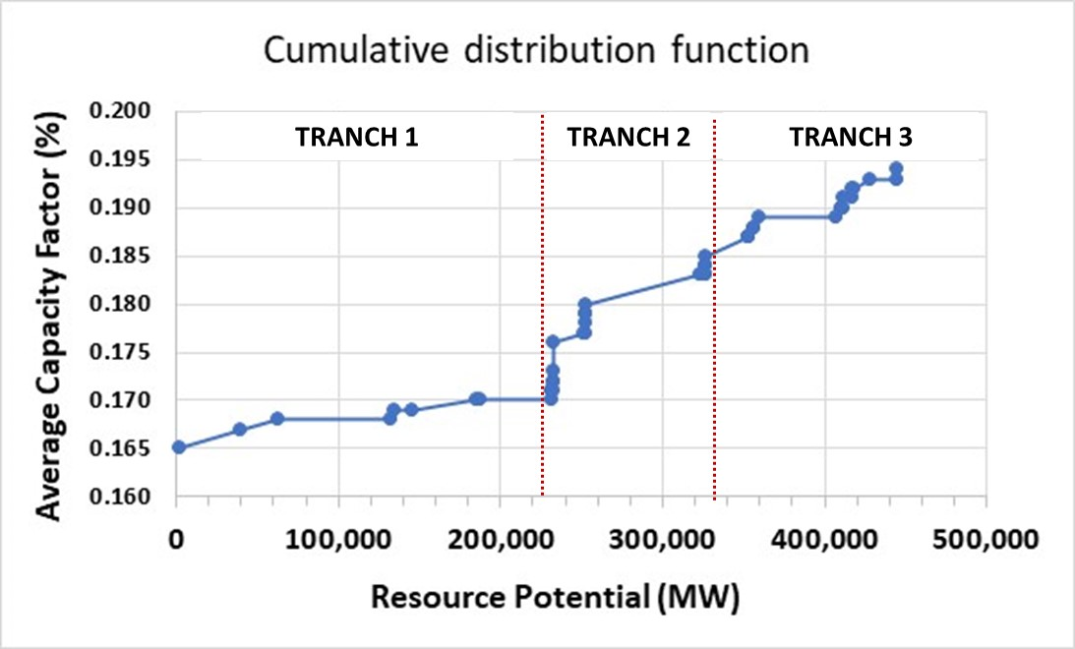

In the case of Kenya, the task team can choose to define only one tranche for the generic solar resource (tranche 3) since the size of the highest quality resource is more than 100 GW and thus more than 5 five times the expected increase in peak demand over the modelling horizon (~ 10 GW).

In case the task team believes the calculated resource potential from the REZoning tool is too conservative and the size of the higher quality resource tranches (tranche 1 and 2 in the example) is low versus the expected increase in peak demand over the modelling horizon, the guideline is to increase the candidate capacity of the tranche with the lowest quality resource (tranche 1 in the above example).

The guideline to assign an hourly profile to each tranche t is as follows:

* Locate the coordinates of a point belonging to tranche t on the webpage of the Global Solar Atlas
* Copy the coordinates into the input window of REninja
* Calculate the profile using REninja (see section 3.2.3.1)

*Tranching of VRE resource potential – onshore wind*

Modelling teams are encouraged to run the REZoning three times (once for each Generic IEC type) and prepare a cumulative distribution function of the maximum average capacity factor across the regions in the country (the average capacity factor in each region is an output of the REZoning tool) and across the 3 runs from the REZoning tool to decide on the cutoff values between tranches. Figure 4 shows an example for Kenya together with a proposed tranching.

Figure 4. Cumulative distribution function for solar resource potential in Kenya (using REZoning)

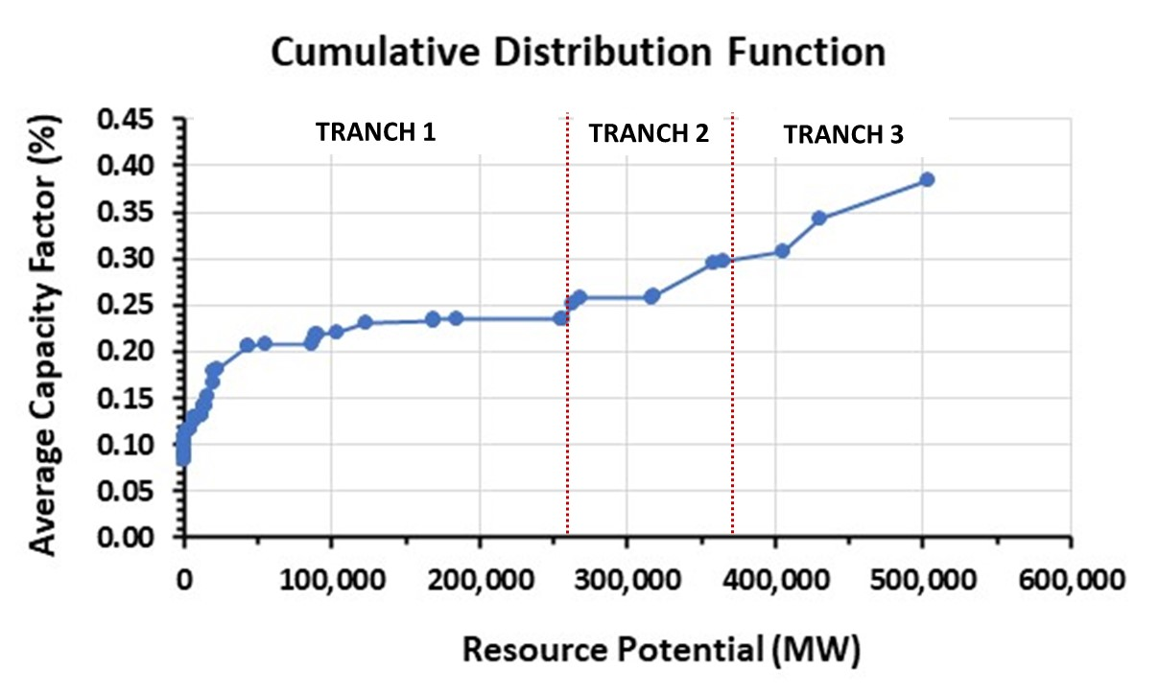

In the case of Kenya, the size of the highest resource quality tranche (tranche 3 with a size of ~ 100 GW) is again much larger than the expected increase in peak demand over the modelling horizon (~ 10 GW). However, even though zones within a tranche could have similar average capacity factors, significantly daily or seasonal differences could exist across zones within the same tranche.[30] Tranche 3 consists of the Garissa, Isiolo, and Marsabit zones. Figure 5 shows the significant seasonal and daily variations between Marsabit and Isiolo on the one hand and Garissa on the other hand. For Kenya the recommendation would be split the high potential tranche into two tranches given the large daily variations across zones in the tranche.

As a result, the recommendation for generic wind candidate plants in Kenya would be to define at least two tranches: the two subtranches of the high-quality tranche as explained above. Task team can still define additional wind resource tranches if other wind resources exist that could be beneficial to the power system.

The definition of such additional wind tranches is guided by the following questions:

* Are there zones having wind resources that could be beneficial to the system given expected seasonal variation of load or output of other supply options (e.g., hydro)?
* Are there zones having wind resources that could be beneficial to the system given expected daily variations of load or output of other supply options (e.g., solar)?

Figure 5. Seasonal and daily profiles for high quality zones in Kenya (using Global Wind Atlas)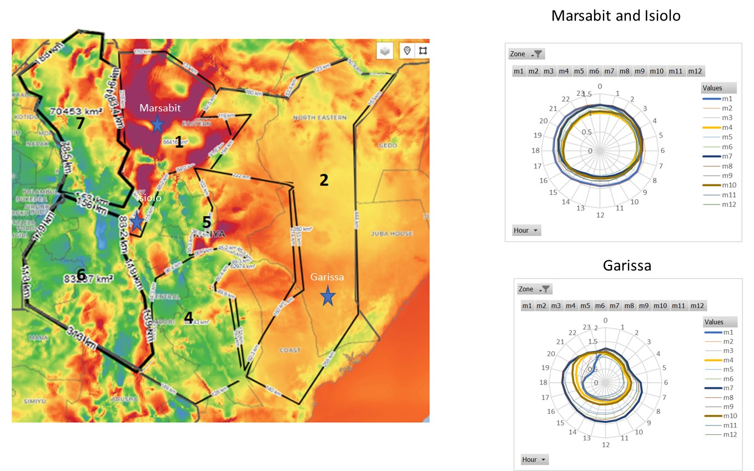

In case the task team believes the calculated resource potential from the REZoning tool is too conservative and the size of the higher quality resource tranches (tranche 1 and 2 in the example) is low versus the expected increase in peak demand over the modelling horizon, the guideline is to increase the candidate capacity of the tranche with the lowest quality resource (tranche 1 in the above example).

The guideline to assign an hourly profile to each tranche t is as follows:

* Locate the coordinates of a point belonging to tranche t on the webpage of the Global Wind Atlas
* Copy the coordinates into the input window of REninja
* Calculate the profile using REninja (see section 3.2.3.1)

#### Capacity credits

Modelling teams should fix capacity credits (CC)[31] according to the following procedure:

1. Use the reported capacity credits by technology from credible country specific reports or inputs from local experts in case such information can be obtained
2. In the likely case where such information is not available, fix the capacity credit for fossil technologies (CCGT, OCGT, ST), nuclear, and biomass at the default maximum technical availability presented in Table 11. The default capacity credit for stored hydro is 90%. For run of river hydro the default is to use 50%. [32]
3. For VRE technologies (wind, solar) the proposed yearly average default values are [33][32]:
   1. Solar PV and rooftop PV: 10%
   2. Onshore wind: 20%
   3. Offshore wind: 20%

Task team should preferably use seasonal capacity credits. Seasonality in the capacity credit values can be introduced by scaling the default yearly average CC value with the ratio of the average seasonal capacity factor of the VRE technology to the yearly average CF capacity factor of the VRE technology.

In case task teams obtained a full hourly load profile (8760 hours of load data points) from a recent year, they are also encouraged to manually calculate the capacity credit for VRE technologies based on the average capacity factor of the VRE technology during hours for which the load is within 10% of the yearly peak load. In case the calculated average capacity credit is significantly different from the proposed yearly average default values, modelling teams can switch the default for the calculated CC in consultation with the country team.

1. The starting default capacity credit for storage technologies is the default maximum technical availability presented in Table 11. However if high RE penetration is expected in the scenario results, it is recommended to scale the battery storage capacity credit down to 80%.

#### CCS

1. Greenfield CCS

Recommended ranges and default values of operational characteristics for new CCS plants are given in Table 12.

1. Retrofit CCS

*Table 8* shows the recommended values for the percentual decrease in operating capacity and percentual increase in heat rate. Ranges and default values for operational characteristics of retrofit CCS plants can be taken equal to the original plants as per Table 12.

1. BECCS

The recommended heat rate is in the range of 10.0 – 13.7 MMBTu per MWh with a default value of 12.5 MMBtu per MWh. Other operational characteristics can be taken equal to the ones for biomass generators listed in Table 10. The default emission factor BECCS is -0.08 ton CO2e per MMBTu based on the study from Garcia-Feites et al [34]. The proposed emission factor of -0.08 ton per MMBtu is a conservative estimate compared to the work from the Global CCS institute for a Canadian case study quoting a negative emission factor of -1.38 ton CO2 per MWh (~ -0.13 ton per MMBtu) [35]. The proposed emission factor is also in line with the recent work from Donnison et al., 2020 stating that “For a 500 MW BECCS power plant operating on local biomass resources. Annually, each BECCS plant requires 2.33 Mt of biomass and generates 2.99 Mt CO2 of negative emissions and 3.72 TWh” [36] giving a negative emission factor of -0.80 ton CO2 per MWh (~ -0.08 ton per MMBtu).

Figure 6. Emission factor for BECCS (95 percent capture rate). [35]

In case task teams want to include BECCS as a candidate technology, they can estimate the maximum candidate BECCS capacity (in case a country has significant biomass development plans) as follows:

1. Start from a conservative estimate of the maximum biomass availability (say 10-20% of the maximum biomass energy potential) if such estimate is available. Afterwards convert the biomass potential in GJ to a BECCS potential in MW (potential in MW can be calculated from the biomass potential in GJ assuming a default heat rate of 12.5 MMBTu per MWh)
2. Set the maximum candidate BECCS capacity to the minimum of 2 GW and 10% of the peak demand by 2050 in case no estimate of the country’s biomass potential is available.

Table 12. Operational characteristics of new generators with CCS. [9] [10] [15] [16]

|  |  |  |  |  |  |  |  |  |  |  |  |
| --- | --- | --- | --- | --- | --- | --- | --- | --- | --- | --- | --- |
| *Technology* | *Fuel* | *Heat rate (MMBTu/MWh)* |  | *Ramp-up rate*  *(% of cap. per hour)* |  | *Ramp-down rate*  *(% of cap. per hour)* |  | *Max. Contribution to reserve (%)* |  | *Minimum generation (%)* |  |
|  |  | *Range* | *Std. Value* | *Range* | *Std. Value* | *Range* | *Std. Value* | *Range* | *Std. Value* | *Range* | *Std. Value* |
| *Coal (ST) – CCS* | *Coal* | 8.9 – 10.9 | 9.9 | 100% | 100% | 100% | 100% | 3-6% | 5% | 10-20% | 10% |
| *CCGT – CCS* | *Gas* | 6.7 – 8.3 | 7.0 | 100% | 100% | 100% | 100% | 8-12% | 10% | 10-40% | 15% |
| *OCGT - CCS* | *Gas* | 9.0 – 10.8 | 9.8 | 100% | 100% | 100% | 100% | 10-20% | 15% | 0-0% | 0% |

## National Policies in APS World – fossil fuel prices

Fossil fuel (natural gas, coal, diesel, HFO) prices should be based on trade-parity costs without subsidies and taxes. The prices should be in real terms and for the base year (first year of the analysis) prices should be in 2022 U.S. dollars. Future free-on-board (FOB) projections of crude oil, natural gas (Henry Hub, Japan LNG, or EU Gas - Dutch Title Transfer Facility), and coal prices should be based on a forecast combining the short-term forecast (up to 2025) from the EFI Prospects Group and the long-term IEA APS scenario values. The default fossil fuel price forecasts for the *National Policies in APS World* scenario are obtained as follows:

* 2023 - 2025: 2023 value and short-term projections (publicly available) from the EFI Prospects Group
* 2026 - 2029: Interpolation between EFI Prospects group 2025 value and the 2030 value from the IEA APS scenario
* 2030 - 2050: values from IEA APS scenario

If recent country specific net-of-tax (or subsidy) fuel prices broken down into cost components are available to the team, the team should use them as the starting point. If not, the realized free-on-board benchmark prices from the EFI Prospects Group relevant for the country in question from the last year for which they are available form the starting point. The IEEGK team will provide the free-on-board prices of various fuels from the most recent year for which prices are available. Either way, these historical prices are adjusted in percentage terms in line with future oil, gas, and coal price projections obtained by combining the short-term EFI forecast and the long-term IEA APS forecast.

In the final step applicable transportation and other costs need to be added to the projected fuel prices. Gas prices could include pipeline costs for pipeline gas or shipping and regasification costs for liquefied natural gas depending on the gas source. Coal, diesel, and HFO prices could include shipping and trucking costs depending on the fuel source. Consultation with local experts is encouraged to get reliable estimates for fuel transportation costs.

Task teams can request IEEGK experts to support the preparation of fuel price forecasts.

## National Policies in APS World – interconnections

A typical power system model requires inputs in terms of internal interconnections and external interconnections (transmission lines with neighboring countries).

### Internal Interconnections

The modelling team needs to include *internal country zones and interconnection capacities* between the internal zones if information on internal zones and their transfer capacities is available from recent master plans, local experts, or existing models within the ESMAP Planning group. In case significant transmission constraints exist in the country or if such constraints are expected to become an important bottleneck to serve major load centers, the model needs to be allowed to endogenously increase the transfer capacity of such internal interconnections throughout the modelling horizon. The investment costs ($ per MW) and earliest commission date for new interconnection capacity need to be estimated from recent local master plan[33], similar greenfield transmission projects, and consultation with local experts. Modelling teams can assume a typical loss factor of 3% for transmission lines in the absence of any data.

### External Interconnections

Transfer capacity (in MW) of existing external interconnectors together with expected transfer capacity (in MW) and commission date of committed external interconnectors need to be included based on information from local master plans, national transmission system operator reports, reports from reputable organizations (IEA, NREL, etc.), or from an experienced consultant with local expertise. In case regional trade (either through increased imports or exports) is an important aspect of the country’s energy future, the model could be allowed to endogenously increase the capacity of such external interconnections throughout the modelling horizon in consultation with the country energy team. The investment costs ($ per MW) and earliest commission date for new external interconnectors needs to be estimated from recent local master plan, similar greenfield transmission projects, and consultation with local experts.

The power system model typically needs the following inputs in case external interconnectors are included in the analysis: *maximum hourly import and maximum yearly import share, maximum hourly export, and electricity trade prices* in the external zones to which the country is connected.

The maximum hourly import and maximum yearly import share need to be determined based on inputs from recent master plans and/or consultations with local experts to account for a) any domestic generation constraints and b) the stability of the country’s network. The maximum hourly export limit should also be set based on inputs from recent master plans, transmission system operator reports, and/or consultations with local experts.

Electricity trade prices in neighboring countries can be calculated using one of the following methodologies in order of preference:

1. Interpolation between projected electricity prices reported in electricity market reports from international consultants, the market operator or the transmission system operator of the neighboring country
2. A weighted average levelized cost of electricity (LCOE) based on the projected electricity generation mix (e.g., if the projected generation mix in year y is 50% gas using CCGT and 50% coal using steam turbines then the trade price in year y is 50% * LCOE of gas using CCGT + 50% * LCOE of coal using steam turbines).
3. Announced or existing PPA prices

## National Policies in APS World – emission factors

Emission factors (EF) in (metric) tCO2e per MMBTU for coal, natural gas and LNG, HFO, and diesel need to be harmonized across decarbonization analyses using reported IPCC values. *Table 13* lists the recommended default emission factors by fossil fuel. Emission factors of solar technologies (utility PV, rooftop PV, and CSP), wind (onshore and offshore), biomass without CCS, and run of river hydro can be assumed to be zero in the absence of any country or project specific information. Emission factors for reservoir hydro can be estimated based on reservoir size, expected plant load factor, and vegetation type using Annex 5.B of the WB Guidance Manual on Greenhouse Gas Accounting for Energy Investment Operations [37][34]. In the absence of project specific data, modelling teams can use an emission factor of 0.86 **kg**CO2e/MMBtu for reservoir hydro.

Table 13. Proposed emission factor for selected fuels. [38]

|  |  |
| --- | --- |
| *Fuel* | *Emission Factor*  *(metric ton* CO2e */MMBtu)* |
| *Gas* | 0.0592 |
| *Coal* | 0.1031 |
| *Diesel* | 0.0784 |
| *HFO* | 0.0819 |
| *Lignite* | 0.1065 |
| *BECCS* | -0.08 |

*Note*: The IPCC Guidelines for National Greenhouse Gas Inventories provide emission factors of other less used fossil fuels (e.g., peat, bitumen, etc.) for stationary combustion.

Emission factors for imports from neighboring countries should be calculated using one of the following methodologies in order of preference:

1. Interpolation between projected emission factors reported in electricity market reports from international consultants or the transmission system operator of the neighboring country
2. A weighted average emission factor of imported electricity based on the projected electricity generation mix (e.g., if the projected generation in year y is 50% gas using CCGT and 50% coal using steam turbines than the import emission factor in year y is 50% * EF of gas using CCGT + 50% * EF of coal using steam turbines)

## National Policies in APS World – discount rate

The default discount rate should be set at 6% for comparability across energy transition analyses as per the guidance for macromodelling in the “Standardizing CCDR Macro Model Presentation” document available on the WB internal CCDR website. Additional discount rates may be used for sensitivity analysis where relevant. The calculation of the discount rate (societal time preference rate) for such sensitivity analyses according to the WB guidelines on discounting is given in Annex 6.

## National Policies in APS World – WACC[35]

Task team should calculate a country specific real WACC *applicable to all generation technologies* using the following equation:

$${WACC}_{real}(decimal value)=A+B∙CRP(decimal value)$$

With A, B: constants (A = 0.0430; B = 0.8981)[36]

CRP: country risk premium.

For consistency and simplicity, the recommendation is to use real WACCs for which the only differentiation among countries is the difference in the country risk premium. The IEEGK team can provide a list of country risk premia.[37] The above equation will result in real WACCs spanning a typical range from 6% to 15%.

## National Policies in APS World – other parameters

Finally, the setup of the *National Policies in APS World* scenario typically requires setting the following parameters:

* Cost of unserved energy (Value of Lost Load): typically in the range of 500 – 10,000 $/MWh. The value should be informed by local Master Plans (if considered credible), reports covering the country’s power system from reputable organizations such as IEA, EIA, IRENA, etc.) or other power system experts with local expertise. In the absence of any reliable data, a recommended default value is 1,000 $/MWh.
* Cost of reserve shortfall: This parameter should be set in the range of 60,000 -100,000 $/MW to reflect the need for additional peaking capacity such as open cycle gas turbines (OCGT). A recommended default value is 100,000 $/MW.
* Cost of surplus energy: 0 $/MWh[38]
* Cost of curtailment: 0 $/MWh
* Planning reserve margin (peak demand margin): typically in the 10 – 20% range of peak demand. The value should be informed by local Master Plans (if considered credible), reports covering the country’s power system from reputable organizations such as IEA, EIA, IRENA, etc.) or other power system experts with local expertise. In the absence of any reliable data, a recommended default value is 15%.

#### Backstop penalty – Direct Air Capture

Even though a backstop penalty will mostly not be activated in the National Policies in APS World scenario (unless the scenario already has emission constraints as part of its setup), a typical power model requires the definition of a backstop penalty across all scenarios irrespective of whether the penalty is activated during the modelling horizon or not. The backstop penalty represents the power system’s most expensive means of reducing GHG emissions across GHG capture technologies. The most expensive technology to capture GHG emissions is assumed to be Direct Air Capture (DAC). Two main DAC technologies exist: solid and liquid DAC. Solid DAC uses solid adsorbent to capture CO2. The captured CO2 is afterwards typically removed from the adsorbent by heating at temperatures between 70 and 100°C. In liquid DAC air is passed through liquid solution to capture the CO2 from the air. Regeneration of the liquid sorbent to release the captured CO2 is done at high temperatures (~ 900°C). The two DAC technologies have different forecasted CAPEX trajectories (Figure 7) with levelized costs for liquid DAC in the range of € 100 – 375 per ton CO2 and levelized costs for solid DAC in the range of € 100 – 350 per ton CO2 for the 2030 – 2050 period.

Figure 7. Forecasted levelized costs for liquid (HT) and solid (LT) DAC [39]Chart, line chart

Description automatically generated

We recommend using a conservative estimate of 280 USD per ton CO2 as the future average levelized cost of DAC for the 2030 -2050 period.[39] The choice for a conservative estimate is driven by the nascent status of the technology, uncertainty around future cost reductions for DAC, and the potential limit on the availability of CO2 storage capacity. This value can be input as the default backstop emission penalty excluding any transportation and storage cost. The total backstop emission penalty is the levelized cost of DAC (default value of 280 USD per ton CO2) plus the cost of transportation and storage. Task teams should consistently use the same CO2 transportation and storage cost for DAC as for CCS technologies. Therefore, in case the task team decides to add a cost premium (cost in $/ton for CO2 transport or transport) on top of the proposed default values for CO2 transport and storage, the same total cost premium (cost premium for transport + cost premium for storage) should be applied to the cost of DAC for consistency.

In addition, the modelling team needs to check if the selected parameters result in significant deployment of DAC. If the significant DAC deployment is forecasted, task teams are encouraged to run a sensitivity with higher levelized costs for DAC.

Finally, modelling teams should ensure that no DAC is deployed to reduce power system emissions before 2035 given the nascent status of the technology in line with the IEA World Economic Outlook 2021.

## National Policies in APS World – Timing parameters

This section summarizes all timing parameters decisions for the *National Policies in APS World* scenario in the below list.

* The cost base year is 2023.
* The modelling horizon spans from 2023 to 2050.
* All results related to total costs and cumulative results over the entire horizon should consider the time horizon from 2023 to 2050.
* Modelling teams are encouraged to split the modelling horizon in time periods of no more than 2 years.
* Ensure generic candidate plants and generic high voltage interconnectors can only be built as from 3 years after the initial year in the modelling horizon (the first potential deployment year for generic plants and interconnectors is thus 2027).
* Ensure economic retirements can only happen as from 3 years after the initial year in the modelling horizon (the first year for economic retirements is thus 2027). Planned retirements as per a recent reputable source are the only allowed retirements within the first 3 years.
* No greenfield or retrofit CCS deployment before 2030.
* No BECCS deployment before 2030.
* No DAC deployment before 2035.
* Define annual build limits as per section 3.2

# Power Decarbonization 2050

## National Power Decarbonization 2050 in NZE World

*National Power Decarbonization in NZE World* (PD2050-NZE) performs a least-cost economic generation expansion optimization under a net zero GHG emission constraint by 2050. Apart from the additional carbon constraints, this standard transition scenario will differ from the *National Policies in APS World* scenario as follows:

* Absolute GHG emission constraints (in Mton CO2e) starting from the fourth year in the modelling horizon (starting year + 3 years) until 2050. The emission constraint in the fourth year is equal to the emissions from the *National Policies in APS World* scenario in the corresponding year. Afterwards the emissions constraint decreases linearly from the fourth-year value down to zero in 2050.
* If considered relevant by the country team, the following impacts on demand will be included in the *PD2050-NZE* scenario:
  + Impact from additional electrification of transport
  + Impact from additional electrification of heating and cooling services (buildings)
  + Impact from additional electrification of industry
* Deep decarbonization in the rest of the world (ROW)

The main differences between *National Policies in APS World* and *National Power Decarbonization 2050 in NZE World* are thus stringent GHG constraints (down to net zero in the power sector by 2050) together with the global view of successful decarbonization and limited warming for the rest of the world (ROW) as per the note on [Priority scenarios for CCDR analyses](https://worldbankgroup.sharepoint.com/sites/WBClimate/Knowledge%20Base/Global%20Scenarios%20for%20CCDR%20Analyses.pdf) (resulting in differences in exogeneous factors such as long term capital costs and fuel prices).

*Differences in exogeneous factors between National Policies in APS World and National Power Decarbonization 2050 in NZE World as a result from deep decarbonization in the rest of the world (4.1.1 and 4.1.2).*

### CAPEX trajectories

Capital cost trajectories should be harmonized across analyses using the recommended relative trajectories (relative versus the initial overnight capital cost) from *Table 4*.[40] The CAPEX trajectories are based on the most recent available data from the IEA World Energy Outlook Net Zero Emission Scenario or NZE (2022) or the NREL Annual Technology Baseline 2023 (ambitious scenario) in line with the recommendation from the CCDR EEX Approaches Note.

The recommendation in terms of capital costs trajectories for other technologies (without CCS) not presented is:

* CCGT, OCGT, ICE: no decrease in capital cost over time (in line with the IEA World Energy Outlook 2022 NZE scenario)
* Coal: no decrease in capital cost over time (in line with the IEA World Energy Outlook 2022 NZE scenario)
* Hydro (both for reservoir, run of river hydro, and pumped hydro): no decrease in capital cost over time (in line with the IEA World Energy Outlook 2022 NZE scenario)
* Nuclear: no decrease in capital cost over time (in line with the IEA World Energy Outlook 2022 NZE scenario)
* CSP, geothermal, and biomass: see Annex 1.

Default CAPEX trajectories for technologies in the *National Power Decarbonization 2050 in NZE World* scenario without CCS are given in Table 14 and with CCS in Table 15.

Table 14. Default CAPEX trajectories for selected technologiesin *National PD2050 in NZE World* scenario.[9][14]

|  |  |  |  |  |  |
| --- | --- | --- | --- | --- | --- |
|  | *Utility PV* | *Rooftop PV* | *Onshore Wind* | *Offshore Wind* | *Battery storage* |
| 2023 | 1.000 | 1.000 | 1.000 | 1.000 | 1.000 |
| 2024 | 0.947 | 0.956 | 0.991 | 0.947 | 0.944 |
| 2025 | 0.894 | 0.912 | 0.981 | 0.893 | 0.896 |
| 2026 | 0.840 | 0.868 | 0.972 | 0.840 | 0.858 |
| 2027 | 0.787 | 0.824 | 0.962 | 0.787 | 0.820 |
| 2028 | 0.734 | 0.780 | 0.953 | 0.733 | 0.782 |
| 2029 | 0.681 | 0.736 | 0.944 | 0.680 | 0.744 |
| 2030 | 0.628 | 0.692 | 0.934 | 0.626 | 0.706 |
| 2031 | 0.618 | 0.648 | 0.931 | 0.617 | 0.693 |
| 2032 | 0.609 | 0.604 | 0.929 | 0.607 | 0.681 |
| 2033 | 0.599 | 0.559 | 0.926 | 0.597 | 0.669 |
| 2034 | 0.589 | 0.515 | 0.923 | 0.587 | 0.656 |
| 2035 | 0.580 | 0.471 | 0.920 | 0.577 | 0.644 |
| 2036 | 0.570 | 0.466 | 0.917 | 0.567 | 0.631 |
| 2037 | 0.561 | 0.461 | 0.914 | 0.558 | 0.619 |
| 2038 | 0.551 | 0.456 | 0.912 | 0.548 | 0.607 |
| 2039 | 0.541 | 0.450 | 0.909 | 0.538 | 0.594 |
| 2040 | 0.532 | 0.445 | 0.906 | 0.528 | 0.582 |
| 2041 | 0.522 | 0.440 | 0.903 | 0.518 | 0.570 |
| 2042 | 0.513 | 0.435 | 0.900 | 0.508 | 0.557 |
| 2043 | 0.503 | 0.429 | 0.898 | 0.499 | 0.545 |
| 2044 | 0.494 | 0.424 | 0.895 | 0.489 | 0.532 |
| 2045 | 0.484 | 0.419 | 0.892 | 0.479 | 0.520 |
| 2046 | 0.474 | 0.414 | 0.889 | 0.469 | 0.508 |
| 2047 | 0.465 | 0.408 | 0.886 | 0.459 | 0.495 |
| 2048 | 0.455 | 0.403 | 0.883 | 0.449 | 0.483 |
| 2049 | 0.446 | 0.398 | 0.881 | 0.440 | 0.471 |
| 2050 | 0.436 | 0.393 | 0.878 | 0.430 | 0.458 |

Table 15. Default CAPEX trajectories for power generation technologies with CCS in National PD2050 in NZE World scenario. [9] [14]

|  |  |  |  |
| --- | --- | --- | --- |
|  | *Coal CCS* | *Gas CCS* | *BECCS* |
| 2023 | 1.000 | 1.000 | 1.000 |
| 2024 | 0.985 | 0.972 | 0.985 |
| 2025 | 0.970 | 0.943 | 0.970 |
| 2026 | 0.956 | 0.915 | 0.956 |
| 2027 | 0.941 | 0.887 | 0.941 |
| 2028 | 0.926 | 0.859 | 0.926 |
| 2029 | 0.911 | 0.830 | 0.911 |
| 2030 | 0.896 | 0.802 | 0.896 |
| 2031 | 0.881 | 0.774 | 0.881 |
| 2032 | 0.867 | 0.745 | 0.867 |
| 2033 | 0.852 | 0.717 | 0.852 |
| 2034 | 0.837 | 0.689 | 0.837 |
| 2035 | 0.822 | 0.661 | 0.822 |
| 2036 | 0.813 | 0.653 | 0.813 |
| 2037 | 0.803 | 0.645 | 0.803 |
| 2038 | 0.794 | 0.637 | 0.794 |
| 2039 | 0.785 | 0.629 | 0.785 |
| 2040 | 0.775 | 0.621 | 0.775 |
| 2041 | 0.766 | 0.613 | 0.766 |
| 2042 | 0.757 | 0.605 | 0.757 |
| 2043 | 0.747 | 0.597 | 0.747 |
| 2044 | 0.738 | 0.589 | 0.738 |
| 2045 | 0.729 | 0.581 | 0.729 |
| 2046 | 0.719 | 0.573 | 0.719 |
| 2047 | 0.710 | 0.565 | 0.710 |
| 2048 | 0.701 | 0.557 | 0.701 |
| 2049 | 0.691 | 0.549 | 0.691 |
| 2050 | 0.682 | 0.541 | 0.682 |

### Fuel prices

The default fossil fuel price forecasts for the *National PD2050 in NZE World* scenario are obtained as follows:

* 2023 - 2025: 2023 value and short-term projections (publicly available) from the EFI Prospects Group
* 2026 - 2029: Interpolation between EFI Prospects group 2025 value and the 2030 value from the **IEA NZE scenario**
* 2030 - 2050: values from **IEA NZE scenario**

If recent country specific net-of-tax (or subsidy) fuel prices broken down into cost components are available to the team, the team should use them as the starting point. If not, the realized free-on-board benchmark prices from the EFI Prospects Group relevant for the country in question from the last year for which they are available form the starting point. The IEEGK team will provide the free-on-board prices of various fuels from the most recent year for which prices are available. Either way, these historical prices are adjusted in percentage terms in line with future oil, gas, and coal price projections obtained by combining the short-term EFI forecast and the long-term IEA NZE forecast.

In the final step applicable transportation and other costs need to be added to the projected fuel prices. Gas prices could include pipeline costs for pipeline gas or shipping and regasification costs for liquefied natural gas depending on the gas source. Coal, diesel, and HFO prices could include shipping and trucking costs depending on the fuel source. Consultation with local experts is encouraged to get reliable estimates for fuel transportation costs.

Task teams can request IEEGK experts to support the preparation of fuel price forecasts.

### Demand projections

The electricity demand for the PD2050 scenario will either be calculated by 1) the WB macroteam or 2) by the task team (with potential support from the IEEGK team). In case of option 2, the modelling team will need to start from the *National Policies in APS World* electricity demand and add the supplemental demand from the relevant sectors (e.g., electrification of transport, electrification of heating and/or cooling, and electrification of industry). The following sections 4.2 - 4.4 describe methodologies to calculate the additional electricity demand from electrification of transport, heating and cooling, and industry respectively.[41] The methodologies described in these sections are default methodologies that can be applied in the absence of better country projections and data. Modelers and country teams are encouraged to carefully judge the methodologies for their applicability in their specific country context.

In case the country team does not consider the above potential impacts on power system demand relevant for the energy transition analysis then demand will be the same in the *National Policies in APS World* and the *National Power Decarbonization 2050 in NZE World* scenarios.[42]

## PD2050-NZEwith electrification of transport (PD2050-NZE-TE)

To derive the transport sector electricity demand in PD2050-NZE-TE, we recommend the methodology described in [40]. The model is implemented in MATLAB/Python, the script and associated Excel files can be obtained from the IEEGK team. The analysis considers road transport and battery electric vehicles. If the need arises, extensions to also include hydrogen-based transport (e.g., for heavy-duty vehicles) can be developed. The proposed methodology is based on static charging profiles for the different vehicle types. While we also propose simplified methods to account for flexibility in charging, a detailed assessment of different charging scenarios (uncontrolled, controlled (V1G), or optimized (V1G + V2G)) or battery swapping (e.g., for 2/3 wheelers) is beyond the scope of the analysis. Simple changes in charging behavior can already contribute substantially to reducing integration costs: IEA analysis has shown that around 60% of the peak load related to EVs could be avoided by shifting the charging period by a few hours from evening to night charging [41].

The hourly EV load is estimated according to the following 4 steps:

* Estimation of the daily EV load for different types of EVs based on fuel efficiency and projected mileage by type of EV
* Development of plug-in profiles for different types of EV use depending on the charging mode (either uncoordinated or coordinated). Uncoordinated plug-in probability profiles are based on literature review. Coordinated profiles are constructed based on the assumptions that users have incentives to charge during off-peak hours
* Conversion of plug-in probability profiles into hourly EV load based on information from steps 1 and 2 above and use of technical specifications for charging technologies.
* Place the EV load on top of conventional load and optimize investments.

The main input parameters to the model to be specified by the user are annual mileage per vehicle type and the number of electric vehicles for the different vehicle types. All other model parameters (e.g., charging frequency, charging times, fuel efficiency) can be kept at their default setting. In the absence of official country data and projections, default parameters for mileage are based on [42] .

The default parameters are listed in Table 16. A bandwidth is provided for mileage, we recommend using the median value if detailed country information cannot be obtained. Fuel efficiency is assumed to improve over the following decades. The share of BEVs over PHEVs is assumed to increase with time.

Table 16. Default parameters for transport electrification in PD2050-NZE-TE.

|  |  |  |  |  |  |  |  |  |
| --- | --- | --- | --- | --- | --- | --- | --- | --- |
|  | Mileage (km/year) | | | Percent of mileage on a weekend day compared  to weekday | Fuel efficiency (kWh/100km) | | Breakdown of total EVs (%) | |
|  | Min | Median | Max |  | 2030 | 2050 | 2030 | 2050 |
| Electric Cars | 8000 | 15000 | 20000 | 85% |  |  |  |  |
| Cars-PHEV | 17,0 | 15,3 | 26% | 0% |
| Cars-BEV | 28,4 | 25,6 | 74% | 100% |
| 2 wheelers | 4000 | 7600 | 12800 | 85% |  |  |  |  |
| 2 wheelers-PHEV | 3,6 | 3,2 | 0% | 0% |
| 2 wheelers BEV | 5,0 | 4,5 | 100% | 100% |
| Bus | 17800 | 48100 | 77400 | 70% |  |  |  |  |
| Bus-PHEV | 87.5 | 79 | 2% | 0% |
| Bus BEV | 152 | 137 | 98% | 100% |

Source: Based on [42] and [40]. BEV = battery electric vehicle; PHEV = plug-in hybrid electric vehicle

Country projections on electric vehicle stock development should be taken from roadmaps from local authorities, respectable international organizations, research institutes or the World Bank transport teams. If through none of these sources a country projection is available, the team may revisit the urgency to include transport electrification in the *Power Decarbonization 2050 in NZE World* demand projection. If the team upon reflection still decides to go ahead with the analysis, we propose a methodology for electric cars and two-wheelers. As there is still an ongoing discussion on the role of hydrogen in road freight transport, we refrain from including it at this stage.

In the absence of country projections on electric vehicle stock development (e.g., from local authorities, respectable international organizations or research institutes), the number of electric vehicles in each model year must be estimated. We estimate the overall number of vehicles using a pre-fitted Gompertz-curve:

$${}_{V_{t}=γθe^{αe^{βGDP_{t}}}+\left(1-θ\right)V_{t-1}}^{}{}$$

Here Vt is the vehicle stock in year t per capita and GDPt is GDP (PPP) per capita in year t. Default parameters for α, β, $γ$ and $θ$ are given in *Table 17* below, which can be used in the absence of country specific studies. For the base year, the vehicle stock must be obtained from the local car registrations data or alternative statistics offices.

Table 17. Gompertz curve parameters for vehicle stock projections.

|  |  |  |  |  |
| --- | --- | --- | --- | --- |
|  | $$α$$ | $$β$$ | $$γ$$ |  |
| Cars | -9 | 0.001 | Country specific saturation level based on vehicles per capita | 0.6 |
| 2 wheelers | -9 | 0.004 | Country specific saturation level based on vehicles per capita | 0.09 |

The adoption rate and share of electric vehicles in the overall vehicle fleet depends on a series of factors, including scrappage rates or policies (e.g., regarding internal combustion engine vehicle sales policies, support for EVs). In principle, the number of electric vehicles can be calculated from the overall vehicle numbers of the previous step via their shares in the overall vehicle fleet. In the absence of country targets, the shares provided in Table 18, with linear interpolation in between approximating an S-curve adoption, can be used.

Table 18. Expected shares of electric vehicles by segment.

|  |  |  |  |  |
| --- | --- | --- | --- | --- |
|  | 2023 | 2030  (Min/IDA-Median-Max/IBRD) | 2040  (Min/IDA-Median-  Max/IBRD) | 2050  (Min/IDA-Median-Max/IBRD) |
| Electric cars | actual | 1%-20%-40% | 25%-80%-85% | 45%-86%-90% |
| 2-wheelers | actual | 54% | 95% | 100% |

While controlled or optimized charging behaviors are important means to reduce the cost of electrifying transport, these are currently not implemented in EPM. Some country teams may however decide to explore load shifting. Two simplified approaches are suggested:

* Load shifting can be implemented by iteratively running a power system model such as EPM and adjusting the transport electricity load profiles manually. The basic idea is to shift load from periods of high marginal costs to periods with lower marginal costs within a given day. An implementation within EPM of a similar idea may become available at a later stage.
* Define the share of EV electricity demand, which can be shifted in time as long as the total demand within a certain time window (e.g., day or week for EV charging) is supplied. We would recommend using values of 45-60%. The team may adjust the numerical values to be more conservative (using lower values) or less conservative (using higher values).

## PD2050-NZE with electrification of heating and cooling services

This section describes a simple approach to derive residential space heating and cooling demand. It thus accounts for an important share of energy demand from the buildings sector. Electrification of water heating, cooking, lighting and other household appliances as well as of energy demand from the services sector are important electrification pathways but not considered here. Future versions of this note may explore these electrification pathways further.

A simple linear approach is used to calculate and project residential building space heating and cooling demands. An Excel sheet with sample calculations highlighting default parameters per region is available from IEEGK. The calibration and projections of residential electricity demand for heating and cooling is based on the following equation:

Electricity demand for residential Heating/Cooling =

Population * (Floorspace per capita) * (Heating/Cooling demand intensity per floorspace) * (Electrification rate of heating/cooling) * (Efficiency of Heating/Cooling Electricity)

where

(Heating/Cooling demand intensity per floorspace) = (HDD/CDD) * (penetration rate heating/cooling) * (Integrated Heat Transfer Coefficient).

Country and regional data from World Bank country teams, statistical offices and surveys should be used. In the absence of these data, default values for the socio-economic and technological input parameters are given below. If statistics for heating and cooling demand are available for the base year, the equations and the default parameters below can also be used to calibrate against the least reliable factors.

* Population, World Bank/UN population projections to 2050
* Floorspace per capita, regional averages based on [43]

|  |  |  |  |
| --- | --- | --- | --- |
| m2/cap | 2023 | 2030 | 2050 |
| AFR | 18 | 20 | 25 |
| LAC | 20 | 25 | 30 |
| ECA | 22 | 27 | 37 |
| SEA | 18 | 20 | 25 |

* Heating Degree Days (HDD)/Cooling Degree Days (CDD)
  + HDD and CDD measure the monthly/annual requirements of space heating and cooling to achieve the indoor temperature points in a particular zone.
  + Heating and cooling degree days can be taken from www.degreedays.net, if there is no country specific data from country offices available.
* Penetration rate of heating and cooling
  + Default penetration rate of heating (taking into account that heating degree days will be low for some of the regions/countries from the table) – all in percent

|  |  |  |  |
| --- | --- | --- | --- |
|  | 2023 | 2030 | 2050 |
| AFR | 95 | 100 | 100 |
| LAC | 95 | 100 | 100 |
| ECA | 95 | 100 | 100 |
| SEA | 95 | 100 | 100 |

* Default access rates to air conditioning, from [43] – all in percent

|  |  |  |  |
| --- | --- | --- | --- |
| % | 2023 | 2030 | 2050 |
| AFR | 2 | 10 | 20 |
| LAC | 22 | 28 | 50 |
| ECA | 18 | 20 | 22 |
| SEA | 20 | 25 | 40 |

* Integrated Heat Transfer Coefficient: reflects the building stock and improvements in the building stock over time, based on [43]

|  |  |  |
| --- | --- | --- |
| W/(m2K) | 2023 | 2050 |
| AFR | 3.3 | 1 |
| LAC | 3 | 0.8 |
| ECA | 1.5 | 0.3 |
| SEA | 3.2 | 0.6 |

* Electrification rate of heating/cooling
  + Electrification rate of cooling = 1
  + Electrification rate of heating, based on [43]– all in percent

|  |  |  |  |
| --- | --- | --- | --- |
|  | 2023 | 2030 | 2050 |
| AFR | 15 | 20 | 20 |
| LAC | 15 | 20 | 25 |
| ECA | 5 | 5 | 20 |
| SEA | 10 | 15 | 20 |

* Energy efficiency coefficient of heating and cooling is based on appliance performances for heating and air conditioning, data based on [43]. The energy efficiency coefficient gives the ratio used for either heating or cooling equipment to describe the amount of useful energy (i.e., heating or cooling output) delivered as a ratio of the energy input (e.g., electricity) to deliver that useful output. For ACs it usually exceeds 1 as ACs mechanically transfer more energy from a heat source (indoor air) to a heat sink (the exterior) than the amount of energy that is used in the mechanical process, a similar reasoning applies to heat pumps.

|  |  |  |
| --- | --- | --- |
| Application | 2023 | 2050 |
| Electricity – Direct heating | 1 | 1 |
| Electricity – Heat pump | 2.5 | 5 |
| Energy efficiency coefficient cooling | 2.7-3 | 4-6 |

**Seasonality of heating and cooling demand:** the annual heating and cooling demand needs to be distributed among typical load days to account for daily and seasonal variation. We propose the following approach:

* Split the additional demand for electric heating/cooling by month or season based on the ratio of the number of degree days to the total degree days in the year.
* Calculate the daily additional demand by dividing the additional seasonal demand by the number of days in the season
* Obtain normalized daily heating profiles by month or season from a reputable source (e.g. <https://data.open-power-system-data.org/when2heat/>)
* Calculate the relative contribution of each hour in the normalized daily heating/cooling profile (relative normalized hourly contribution).
* Calculate the additional electricity demand in each load block as:

Additional electricity demand in load block = (relative normalized hourly contribution space heating/cooling) x (seasonal electric heating/cooling demand)

* Divide the additional electricity demand in each load block by its duration to get the additional power demand in each load block (MW)

## PD2050-NZE with electrification of industry

Depending on country specifics, e.g., a high share of industrial emissions, task teams may want to assess whether electrification of industry, or the exploration of the potential for electrification, should be a priority for a developing country.

Assessing the potential for electrification of industry requires a deep understanding of the process level details across the heterogenous applications. As detailed industrial sub-sectoral and process level data is in most cases not readily available, we recommend a simplified approach in which we derive electricity consumption in industry via its share in overall industry consumption. We recommend assuming a linear increase to a value of 40% by 2050 based on the IEA Net Zero by 2050 scenario in the absence of specific country targets. Task teams are encouraged to use higher values if credible strategies for industrial electrification exist in the country under investigation. An improvement is possible if a distinction between light and heavy industry is available. The share of electricity in light industry demand is generally higher due to the higher share of low temperature heat which is in turn easier to electrify. Shares for light industry could reach up to 70% in overall industry demand (IEA Net Zero by 2050 Scenario).

Overall industry energy consumption is based on country projections. In the absence of country projections on overall industry demand, overall industry demand growth must be derived using GDP growth rates or IEA industry demand growth rates from the respective regional Sustainable Development Scenario results.

Refinements to this simple approach are possible if further industrial subsector splits are available. Please note these are undeveloped methodologies and they are most likely not feasible to implement within this FY. Possible extensions include a more refined assessment of the demand for green hydrogen and electricity in iron and steel and fertilizer production.

Load profile changes due to electrification of industry are difficult to assess due to a lack of data. The default assumption will be that electricity demand increases from electrification of industry are evenly distributed throughout the year.

## PD2050-NZE with Green Hydrogen

Modelling teams should include green hydrogen in their CCDR energy transition analysis if the country team believes the country under investigation has either credible hydrogen production plans and targets or hydrogen import plans. The recommendation is to focus on green hydrogen since the majority (>70%) of the low-emissions hydrogen will be produced via electrolysis (so-called green hydrogen) by 2050 in the the IEA Net Zero scenario.[43]

### Green hydrogen production

Three technologies hold the most potential for green hydrogen electrolysis: alkaline electrolysis (AE), proton exchange membrane electrolyzers (PEM or PEMEL), and solid oxide electrolyzers (SOEL). Recommended cost characteristics for these 3 technologies are summarized in Table 19. The recommended default availability for all electrolyzers is 95%.

Table 19. Recommended cost characteristics for green hydrogen electrolyzers [44] [45] [46].

|  |  |  |  |  |  |
| --- | --- | --- | --- | --- | --- |
| **Electrolyzer** | **Conversion Rate (MMBTu-H2/MWh_e)** | **Fixed O&M**  **(% of CAPEX)** | **Variable O&M ($/mmBTU_H2)** | **Capex (M$/MW)** | **Economic Life (Years)** |
| AE | 2.73 | 2-5% (4%)** | 0.05-0.70 (0.40)*** | 0.95 | 13 |
| PEM | 2.52 | 2-5% (4%)** | 0.05-0.70 (0.40)*** | 1.18 | 13 |
| SOEL | 3.07 | 2-5% (4%)** | 0.05-0.70 (0.40)*** | 2.20 | 9 |

*: Using a conversion of 0.1345 MMBTu per kg H2 (Higher Heating Value).

**: Recommended default value

***: Includes the cost of water, compression, and on-site storage, recommended default value in brackets. Estimates for costs of water, compression-only, and on-site storage are given in [46].

Numerous capital cost trajectories for hydrogen electrolyzers are available in the literature. Table 20 lists expected capital cost trajectories from the World energy Council (WEC) [44] and a recommended default capital cost trajectory for electrolyzers prepared in consultation with ESMAP experts.

Table 20. Capital cost trajectories for green hydrogen electrolyzers.

|  |  |  |  |  |  |  |  |
| --- | --- | --- | --- | --- | --- | --- | --- |
|  | *WEC-Average (AE)* | *WEC-High*  *(AE)* | *WEC-Low*  *(AE)* | *WEC-Average (PEM)* | *WEC-High*  *(PEM)* | *WEC-Low*  *(PEM)* | *Default* |
| 2023 | 1.000 | 1.000 | 1.000 | 1.000 | 1.000 | 1.000 | 1.000 |
| 2024 | 0.937 | 0.950 | 0.903 | 0.962 | 0.973 | 0.941 | 0.961 |
| 2025 | 0.873 | 0.900 | 0.806 | 0.923 | 0.946 | 0.882 | 0.922 |
| 2026 | 0.810 | 0.851 | 0.709 | 0.885 | 0.920 | 0.824 | 0.883 |
| 2027 | 0.746 | 0.801 | 0.612 | 0.847 | 0.893 | 0.765 | 0.844 |
| 2028 | 0.683 | 0.751 | 0.515 | 0.808 | 0.866 | 0.706 | 0.805 |
| 2029 | 0.629 | 0.701 | 0.453 | 0.770 | 0.839 | 0.647 | 0.766 |
| 2030 | 0.600 | 0.663 | 0.444 | 0.736 | 0.814 | 0.599 | 0.727 |
| 2031 | 0.590 | 0.654 | 0.435 | 0.717 | 0.796 | 0.578 | 0.717 |
| 2032 | 0.580 | 0.644 | 0.426 | 0.698 | 0.779 | 0.557 | 0.706 |
| 2033 | 0.571 | 0.634 | 0.417 | 0.680 | 0.761 | 0.535 | 0.696 |
| 2034 | 0.561 | 0.624 | 0.408 | 0.661 | 0.744 | 0.514 | 0.686 |
| 2035 | 0.552 | 0.614 | 0.399 | 0.642 | 0.726 | 0.492 | 0.675 |
| 2036 | 0.542 | 0.604 | 0.389 | 0.623 | 0.709 | 0.471 | 0.665 |
| 2037 | 0.532 | 0.595 | 0.380 | 0.604 | 0.691 | 0.450 | 0.655 |
| 2038 | 0.523 | 0.585 | 0.371 | 0.585 | 0.674 | 0.428 | 0.644 |
| 2039 | 0.513 | 0.575 | 0.362 | 0.566 | 0.656 | 0.407 | 0.634 |
| 2040 | 0.503 | 0.565 | 0.353 | 0.547 | 0.639 | 0.386 | 0.623 |
| 2041 | 0.494 | 0.555 | 0.344 | 0.529 | 0.621 | 0.364 | 0.613 |
| 2042 | 0.484 | 0.545 | 0.335 | 0.510 | 0.604 | 0.343 | 0.603 |
| 2043 | 0.475 | 0.536 | 0.326 | 0.491 | 0.586 | 0.321 | 0.592 |
| 2044 | 0.465 | 0.526 | 0.316 | 0.472 | 0.569 | 0.300 | 0.582 |
| 2045 | 0.455 | 0.516 | 0.307 | 0.453 | 0.552 | 0.279 | 0.571 |
| 2046 | 0.446 | 0.506 | 0.298 | 0.434 | 0.534 | 0.257 | 0.561 |
| 2047 | 0.436 | 0.496 | 0.289 | 0.415 | 0.517 | 0.236 | 0.551 |
| 2048 | 0.427 | 0.486 | 0.280 | 0.396 | 0.499 | 0.215 | 0.540 |
| 2049 | 0.417 | 0.477 | 0.271 | 0.377 | 0.482 | 0.193 | 0.530 |
| 2050 | 0.407 | 0.467 | 0.262 | 0.359 | 0.464 | 0.172 | 0.519 |

### 4.5.2 Green hydrogen import

A multitude of green hydrogen projections is available from different sources (IRENA, BNEF, WEC, etc.) with green hydrogen production prices (excluding transportation costs) in the range of 1-4$/kg H2 by 2050. Transportation by pipeline in large volumes can be cheap (<0.5 $/kg H2) but transportation by ship is expected to cost at least 1.5 $/kg H2 [47]. In the absence of country specific projections, lists a recommended price trajectory for green hydrogen (assuming a fixed transportation cost of 1.5 $/kg H2).

Table 21. Proposed price trajectory for landed green hydrogen.

|  |  |
| --- | --- |
|  | *Full cost of Green hydrogen (USD/MMBtu)* |
| 2025 | 56.3 |
| 2026 | 55.2 |
| 2027 | 54.2 |
| 2028 | 53.2 |
| 2029 | 52.1 |
| 2030 | 47.8 |
| 2031 | 47.4 |
| 2032 | 46.9 |
| 2033 | 46.4 |
| 2034 | 46.0 |
| 2035 | 45.6 |
| 2036 | 45.2 |
| 2037 | 44.8 |
| 2038 | 44.4 |
| 2039 | 44.0 |
| 2040 | 43.6 |
| 2041 | 43.2 |
| 2042 | 42.8 |
| 2043 | 42.4 |
| 2044 | 56.3 |
| 2045 | 55.2 |
| 2046 | 54.2 |
| 2047 | 53.2 |
| 2048 | 52.1 |
| 2049 | 51.1 |
| 2050 | 50.7 |

## PD2050-NZE scenarios – Timing parameters

This section summarizes all timing parameters decisions for the *Power Decarbonization* *2050* scenario in the below list.

* The cost base year is 2023.
* All results related to total costs and cumulative results over the entire horizon should consider the time horizon from 2023 to 2050.
* The modelling horizon spans from 2023 to **2060**. Modelling teams should preferably run *PD2050-NZE* ten years beyond the net zero target year to minimize end of horizon issues. Potential end of horizon issues include the deployment of large capital intensive technologies or significant load shedding in the last couple of years before 2050.[44] Initial analysis of the IEEGK team shows that extension of the modelling horizon does not have a significant impact on the results in the last 10 years of the modelling horizon for smaller power systems such as Ghana and Morocco (Annex 4). Differences can however be more important in larger power system as demonstrated by the analysis for Turkey in Annex 4. Therefore, modelling teams should run the *PD2050-NZE* and preferably all scenarios different from the *National Policies in APS World* scenario case up to at least 2060. Modelling teams can follow these guidelines to extend the time horizon post 2050:
  + Keep the net zero emission criterion post 2050
  + Freeze load profiles, CAPEX trajectories, fuel prices and fuel limits, transmission limits (internal and external), transmission loss factors, electricity trade prices, and reserve requirements at their 2050 values
  + Peak demand projections post 2050 can be obtained by assuming a growth rate equal to the minimum of 2% and the forecasted average peak demand growth rate over the 2040-2050 period.
* Modelling teams are encouraged to split the modelling horizon in time periods of no more than 2 years.
* Ensure generic candidate plants and generic high voltage interconnectors can only be built as from 3 years after the initial year in the modelling horizon (the first potential deployment year for generic plants and interconnectors is thus 2027).
* Ensure economic retirements can only happen as from 3 years after the initial year in the modelling horizon (the first year for economic retirements is thus 2027). Planned retirements as per a recent reputable source are the only allowed retirements within the first 3 years.
* No greenfield or retrofit CCS deployment before 2030.
* No BECCS deployment before 2030.
* No DAC deployment before 2035.
* Define annual build limits as per section 3.2

# Country-specific scenarios

Based on the needs and constraints of the CCDR, task teams may run any number of country-specific scenarios.

An unconstrained scenario, which does not include policy constraints but may include operational constraints, is often used to calculate the economic cost of decarbonization. A scenario portraying a country’s NDC may be desirable, however, many NDCs do not contain complete specificity on the energy sector or power sector requiring some assumptions to approximate.

Possible variations on emissions constrained scenarios include:

* Other emission trajectories towards net zero in the power sector by 2050 – convex or concave emission trajectories
* Different target years for net zero emissions from the power sector
* Emission budget constraints

Electrification scenarios include:

* Power Decarbonization 2050 with Transport electrification
* Power Decarbonization 2050 with Transport electrification and coordinated charging
* Power Decarbonization 2050 with electrification of Heating and Cooling
* Power Decarbonization 2050 with Industrial electrification

Other potentially relevant CCDR scenarios include:

* Constrained gas – constrained on volume or high price
* Reduced hydro availability as a result of climate change
* Locational constraints on coal phase out
* Increased interconnectivity with neighboring countries (regional integration)
* Impact of additional energy efficiency measures

# Sensitivity analyses

In our context, sensitivity analyses are performed to validate the robustness (or not) of scenario results. They differ from scenarios in that only one variable is changed at a time to understand the impact of that change on a particular result, typically the capacity mix or the total investment cost. If a sensitivity analysis reveals a strong impact, modelers should highlight potential policy recommendations (e.g., invest in increasing thermal plant flexibility, research resource potential).

Potential interesting sensitivities that could impact the cost of the energy transition include:

* A lower operational flexibility of certain thermal power plants such as coal-fired plants or
* A different resource potential for renewable resources such as solar (utility and rooftop), wind (onshore and offshore), hydro or biomass or
* Different CAPEX trajectories for selected technologies or
* Different limits in terms of allowed import or
* Different capital or operational costs for carbon capture and storage (CCS) or
* Increased demand from the production of green hydrogen or
* In or exclusion of different technology options for candidate plants or
* Different discount rates than the standard value of 6%

# Outputs

The minimum outputs for each scenario in line with the [CCDR reporting guidelines](https://worldbankgroup.sharepoint.com/sites/WBClimate/Knowledge%20Base/CCDR%20Reporting%20Guidance%202023.pdf) are as follows:

* Grid electricity demand (including for export) in TWh per year broken down between organic demand and if relevant additional demand from electrification of transport, electrification of heating and cooling services, and electrification of industry
* Power system greenhouse gas emissions (in MtonCO2e per year) from grid connected power plants
* Grid emissions factor (gCO2e per kWh)
* Share of grid connected generation from variable renewable sources in the electricity generation mix (in percent)
* Installed grid connected capacity (MW) broken down between solar (utility PV, rooftop PV and CSP), wind (on and offshore), hydropower (ROR and stored hydro), other renewables (e.g. biomass, geothermal, etc.), coal-based generation, oil products (e.g. HFO, diesel, LFO, etc.) based generation, unabated gas-based generation, gas-based generation with CCS (both new and retrofit CCS), nuclear, and storage (e.g. battery energy storage systems, pumped hydro, storage connected to CSP, etc.)
* Total capex for generation and large transmission interconnectors[45] (billion USD cost base year YYYY, cumulative over base year YYYY-2030, 2031-2040, 2041-2050)
* Present value of total system costs for generation and large transmission interconnectors (billion USDcost base year YYYY,cumulative over base year YYYY-2030, 2031-2040, 2041-2050)
* Retirement of coal-fired capacity (MW, cumulative over base year YYYY-2030, 2031-2040, 2041-2050)
* Marginal cost of GHG emissions abatement (USDcost base year YYYY per tCO2e, average over base year YYYY-2030, 2031-2040, 2041-2050)
* Backstop technology cost (USDcost base year YYYY per tCO2e)
* Description of key assumptions in terms of sector scope, energy efficiency, rest of the world mitigation pathway, fuel prices, carbon policies, cost differences across technologies, physical climate changes, adaptation measures, policy and institutional setting, and backstop technology cost (USDcost base year YYYY per tCO2e).

Figure 8 shows an example of the minimum outputs for a hypothetical country.[46] In addition, teams are encouraged to report emissions as well for every 5-year period post 2030 and report investments as a share of GDP. The IEEGK team is also working on methods to estimate the required level of concessional finance to minimize the cost of the energy transition. Annex 5 details the calculation methodology to estimate the concessional financing needs.

In case stranded fossil generation assets are an important part of the analysis, annex 2 provides a detailed calculation framework to calculate the economic value of stranded assets.

The IEEGK team is also working on further guidance to estimate the associated transmission and distribution costs across scenarios. Annex 3 will be enhanced over the coming months to provide support to task teams.

Figure 8. Sample outputs from ascenario.



# Scenario comparison and results analysis

1. Comparison of scenarios

Figure 9 explains how task teams can calculate the implementation gap, ambition gap, and economic cost of decarbonization by comparing total system costs and emissions across scenarios.

The difference between the National Policies in APS World and the NDC scenario (to be run in an APS world) represents the implementation gap in terms of GHG emission reductions the country under investigation still needs to close in case the country’s NDCs cannot be considered as actionable policies that are included in the National Policies in APS World scenario. The difference in cost between the two scenario is the associated cost for the country to close the implementation gap. Similarly, the difference in GHG emissions between the NDC scenario and the National Power Decarbonization 2050 in NZE World shows the remaining ambition gap the country still needs to close in terms of GHG reductions to reach net zero emissions in the power sector by 2050.

The economic cost of decarbonization can be calculated as the difference in cost between an unconstrained least-cost optimization without any climate action in the country under investigation in an APS world and a *National Power Decarbonization 2050* scenario. It is preferable to calculate this difference as a cost range with:

* One end of the range is the difference in cost between the unconstrained least-cost optimization in APS world and the *National PD2050 in NZE World*
* The other end of the range is the difference in cost between the *National PD2050 in an APS World*with the same CAPEX and fuel prices assumptions under the harmonized National Policies in APS World scenario.

In the presence of time constraints, the advice is to calculate the cost of decarbonization as the difference in cost between the unconstrained least-cost optimization in APS world and the *National PD2050 in NZE World*.

Figure 9. Comparison across scenarios to calculate implementation gap, ambition gap, and economic cost of decarbonization.

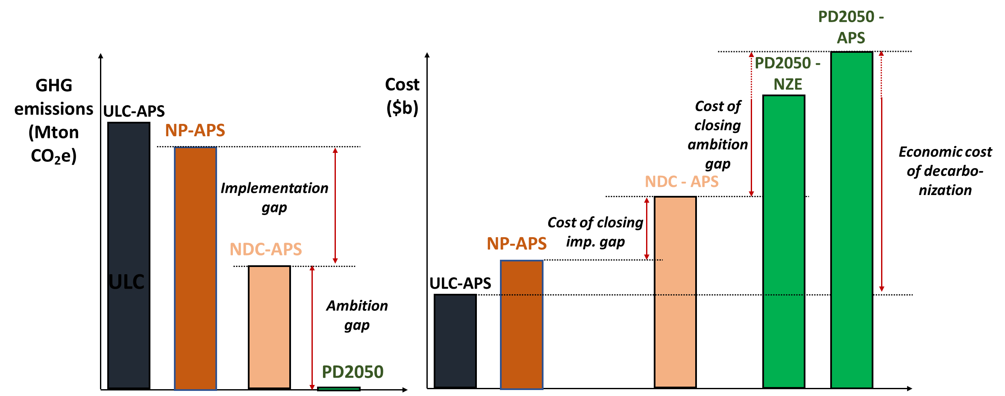

Note: *ULC-APS = unconstrained least cost in APS World; NP-APS = National Policies in APS World: NDC = nationally determined contributions; PD2050 = Power Decarbonization 2050 (either in NZE or APS World)*. The dotted red arrow on the right shows how to represent the economic cost of decarbonization as a range with the bottom of the range determined by the starting point of the dotted red arrow and the end point by the top point of the dotted red arrow. Note that we have shown the PD2050-NZE to have a lower total cost than the PD2050-APS, but this will not necessarily be the case (the order might be reversed depending on the applicable OPEX and CAPEX assumptions for the country under investigation).

1. Guidance for result analysis

The IEEGK team has prepared a template for a power point presentation to explain the results of the modelling exercises and can share presentations from past CCDR analyses.

# Collaboration with the macrofiscal team

The expectation is that more and more countries will link the energy and/or power sector modelling with the macrofiscal model during FY23. Task teams are encouraged to engage with the macrofiscal team as soon as possible to agree on scenarios, inputs (e.g., fuel prices, see 3.3) and results sharing, and the type of linkage[47] between the analyses from the task team and the macrofiscal team.

The current default assumption is that team will soft link the energy/power sector model with the macrofiscal model. Task teams are expected to share technology cost assumptions, and resulting yearly installed capacity by type, generation by type, CAPEX by type, emissions, and electricity cost, with the macrofiscal team for agreed common scenarios.

The below Figure 10 and Figure 11 show the interactions between the macro team and the modelling team for the NP-APS and PD2050-NZE scenarios.

Figure 10. Interaction between modelling team and macro team for AP scenario.

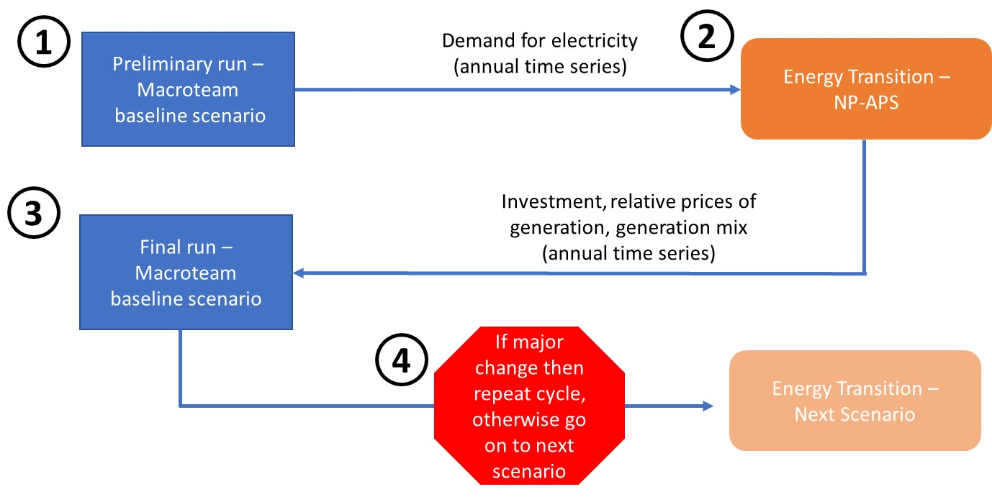

Note: *Blue boxes indicate macro team’s actions. All other boxes are actions for the modelling team.*

Figure 11. Interaction between modelling team and macro team for PD2050-NZE scenario.

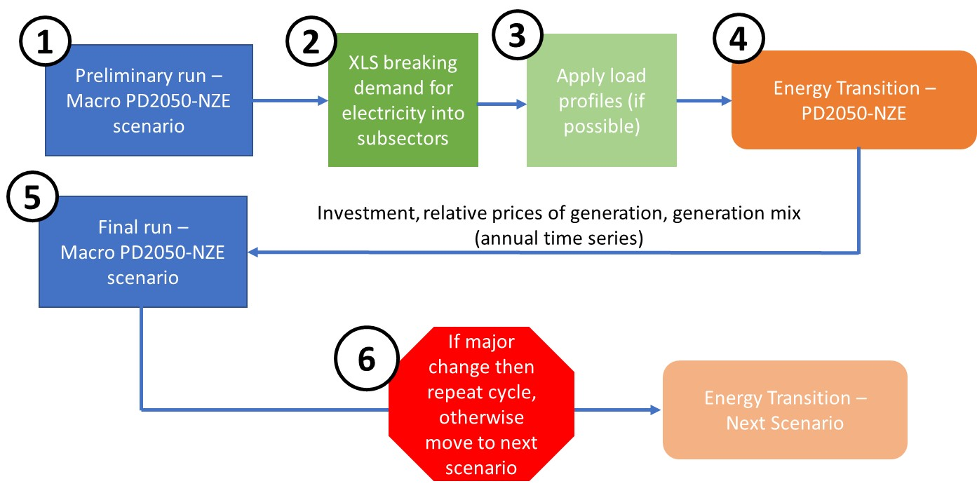

Note: *Blue boxes indicate macro team’s actions. All other boxes are actions for the modelling team.*

# Additional topics for further analysis in coming FYs

The below list combines topics the IEEGK team will consider for further analysis in upcoming FYs if country specific analyses require a dedicated deep dive:

* **Financial and distributional implications of the energy transition.** The modelling approach presented in this note is based on economic values. Such modelling is not well suited to analyze the financial and distributional implications of the energy transition. A supplemental analysis based on financial values (e.g., incorporating financial contracts) could be beneficial. Modelling based on financial values is especially important for utilities as their main consideration is their own financial performance and health more so than costs and benefits at the societal level.
* **Extension of the number of harmonized scenarios to capture different global evolutions in relation with national policies.** This note provides ranges for operational characteristics, technical availability, and CAPEX trajectories assuming a certain future for the rest of the world. It could be useful to propose an additional set of scenarios that represent more optimistic or pessimistic futures for the rest of the world in relation to the selected national policies. These alternative “futures” could be up to the discretion of the CCDR energy team to define, but the intent would be to come up with more optimistic and pessimistic views of key factors. This would lead to additional harmonized scenarios.
* **Quantification of global and local externalities.** In future analyses it could be important to quantify local and global environmental damage costs. CGE models provide estimates of externalities, but these estimates are typically aggregated and do not necessarily provide helpful insights for the energy sector. The valuation of both local and global externalities is extremely important for understanding the distributional implications of the energy transition and can be a useful tool in the dialogue with the client government.
* **Impact of climate change on operational characteristics of power plants and demand.** Until now, only few CCDRs have performed a detailed analysis of the impacts of climate change on demand and the availability of power systems (power plants but also transmission and distribution assets) together.

# Annex 1. Additional CAPEX trajectories

Table 21. Default CAPEX trajectories for selected technologies in National Policies in APS World. [9]

|  |  |  |  |
| --- | --- | --- | --- |
|  | *CSP* | *Geothermal* | *Biomass* |
| 2023 | 1.000 | 1.000 | 1.000 |
| 2024 | 0.964 | 0.974 | 0.964 |
| 2025 | 0.929 | 0.952 | 0.936 |
| 2026 | 0.893 | 0.932 | 0.918 |
| 2027 | 0.857 | 0.915 | 0.909 |
| 2028 | 0.821 | 0.899 | 0.903 |
| 2029 | 0.786 | 0.885 | 0.898 |
| 2030 | 0.750 | 0.872 | 0.892 |
| 2031 | 0.745 | 0.860 | 0.885 |
| 2032 | 0.739 | 0.849 | 0.879 |
| 2033 | 0.734 | 0.839 | 0.874 |
| 2034 | 0.729 | 0.830 | 0.868 |
| 2035 | 0.723 | 0.821 | 0.863 |
| 2036 | 0.718 | 0.817 | 0.856 |
| 2037 | 0.713 | 0.813 | 0.850 |
| 2038 | 0.707 | 0.809 | 0.844 |
| 2039 | 0.702 | 0.805 | 0.838 |
| 2040 | 0.696 | 0.801 | 0.832 |
| 2041 | 0.691 | 0.797 | 0.827 |
| 2042 | 0.686 | 0.793 | 0.821 |
| 2043 | 0.680 | 0.789 | 0.815 |
| 2044 | 0.675 | 0.785 | 0.810 |
| 2045 | 0.670 | 0.781 | 0.803 |
| 2046 | 0.664 | 0.777 | 0.797 |
| 2047 | 0.659 | 0.773 | 0.792 |
| 2048 | 0.654 | 0.769 | 0.786 |
| 2049 | 0.648 | 0.765 | 0.779 |
| 2050 | 0.643 | 0.761 | 0.769 |

Table 22. Default CAPEX trajectories for selected technologies in National PD2050 in NZE World. [9]

|  |  |  |  |
| --- | --- | --- | --- |
|  | *CSP* | *Geothermal* | *Biomass* |
| 2023 | 1.000 | 1.000 | 1.000 |
| 2024 | 0.946 | 0.966 | 0.964 |
| 2025 | 0.892 | 0.936 | 0.936 |
| 2026 | 0.837 | 0.908 | 0.918 |
| 2027 | 0.783 | 0.882 | 0.909 |
| 2028 | 0.729 | 0.859 | 0.903 |
| 2029 | 0.675 | 0.837 | 0.898 |
| 2030 | 0.621 | 0.817 | 0.892 |
| 2031 | 0.613 | 0.798 | 0.885 |
| 2032 | 0.605 | 0.780 | 0.879 |
| 2033 | 0.597 | 0.764 | 0.874 |
| 2034 | 0.590 | 0.748 | 0.868 |
| 2035 | 0.582 | 0.734 | 0.863 |
| 2036 | 0.574 | 0.730 | 0.856 |
| 2037 | 0.566 | 0.727 | 0.850 |
| 2038 | 0.559 | 0.723 | 0.844 |
| 2039 | 0.551 | 0.719 | 0.838 |
| 2040 | 0.543 | 0.716 | 0.832 |
| 2041 | 0.535 | 0.712 | 0.827 |
| 2042 | 0.528 | 0.709 | 0.821 |
| 2043 | 0.520 | 0.705 | 0.815 |
| 2044 | 0.512 | 0.701 | 0.810 |
| 2045 | 0.504 | 0.698 | 0.803 |
| 2046 | 0.497 | 0.694 | 0.797 |
| 2047 | 0.489 | 0.691 | 0.792 |
| 2048 | 0.481 | 0.688 | 0.786 |
| 2049 | 0.473 | 0.684 | 0.779 |
| 2050 | 0.466 | 0.681 | 0.769 |

# Annex 2. Calculation of economic value of stranded assets.

1. Conceptual summary

The economic value of the stranded costs associated with an existing electricity generation asset in the context of decarbonization analyses is defined as the parcel of its non-depreciated capital expenditures that cannot be offset via future creation of economic benefits, considering that the asset will be optimally managed from a societal point of view[48]. More formally, this corresponds to the difference between:

* The parcel of capital expenditures that is not yet depreciated at the time when the stranded costs are estimated[49]; and
* The present value, seen at the instant of the estimation, of all future net benefits (benefits minus costs) that will be obtained if the asset is optimally managed from a societal point of view.

An asset can only be considered stranded if this difference is positive, meaning that future value creation cannot offset sunk costs that have not yet been recovered at the time of the analysis. If the difference is zero or negative, the asset is not stranded, and it is not meaningful to refer to stranded costs.

To evaluate the stranded costs associated with the entire generation segment in a given electricity system, one needs to sum the stranded costs associated with every generator in the system, excluding those for which the abovementioned difference is negative (as these are not stranded assets).

The concept of stranded costs is frequently used in the context of policy changes, including but not limited to decarbonization, that result in the offset impossibility mentioned in the first paragraph. One possible way to estimate the economic value of stranded costs due to any given policy is to estimate the value of stranded costs when that policy enforced and when it is not enforced, then calculate the difference between these two quantities. This is the approach recommended for estimating the stranded costs due to decarbonization efforts in this document.[50]

The mathematical implementation of this conceptual framework is detailed in section C. But first, section B highlights constraints and objectives guiding the development of the estimation method.

1. Objectives and constraints

The objective of the proposed method is to estimate the economic value of stranded costs associated with all generation assets in a given electricity system, *using the information available as a result of the expansion planning efforts during the energy transition analysis*. The method should also estimate the increment in stranded costs attributable to efforts to decarbonize the electricity system, for a given scenario.

The desire to obtain a fast approximation of stranded costs, based on readily available and validated information, is the main reason for proposing a method that uses solely the information from the decarbonization analysis. Yet, making exclusive use of this information constraints the development and application of the method. The most relevant constraints are indicated in the table below.

Table 23. Constraints resulting from exclusive use of information available from DP PASA expansion planning efforts and impacts over development and application of method for estimating stranded costs.

| # | Constraint | Impact |
| --- | --- | --- |
| 1 | Energy transition analyses expansion plans minimize economic costs. Data required for financial analyses are often not collected or readily available. | Method estimates economic value of stranded costs,  as information for financial analyses is not available. |
| 2 | Energy transition analyses produces expansion plans for: different scenarios | Comparison of results from *across* scenarios allows estimating the stranded costs attributable to the changes in policies/constraints across scenarios. |
| 3 | Optimization models used in the energy transition analyses typically consider economic retirement of each existing power plants as a decision variable, informing the optimal retirement schedule as part of the expansion plan. | Year of economic retirement of existing capacity is  an output of the planning model and will be used  as input for the estimation of stranded costs. |
| 4 | Time horizon of expansion plans typically ends in 2050. | Combined with approach of only considering assets whose economic retirement occurs during the planning horizon as stranded, this results in the estimates being a lower bound for actual stranded costs. |
| 5 | Models and databases used in energy transition analyses typically focus only on electricity generation system; the representation of electricity transmission is simplified and there is no direct representation of other energy infrastructure. | Estimation of stranded costs focuses on generation assets. Assets of other classes that are directly and univocally associated to a generation asset, such as transmission infrastructure to connect a generator to the transmission grid, can be factored into the analysis in approximated way. |
| 6 | Models and databases used in energy transition analyses do not necessarily consider possible economic benefits of repurposing assets upon retirement as generators[51], nor the economic costs incurred upon retirement[52]. | This can lead to under- or overestimation of stranded costs[53]:   * The decision on the optimal retirement year of a given power plant, which is an output of the planning model, may not exactly correspond to the social optimum due to not capturing these costs and benefits. Estimates of stranded costs will be affected accordingly, as they use the decision of planning model as an input. * The method for estimating of the economic value of stranded costs will not consider these costs and benefits either, as data is not available. |
| 7 | Models and databases used in energy transition analyses could capture short-term power system operations phenomena that can affect decisions to retire thermal plants with a level of approximation that might affect decisions on retirement years. | The decision on the optimal retirement year of a power plant, which is an output of the planning model, may not exactly correspond to the global optimum due to approximations. Estimates of stranded costs will be affected accordingly, as they use the decision of planning model as an input. This can lead to under- or overestimations[54]. |

Table 21 alludes to three important particularities of the proposed method for estimating stranded costs:

* The method estimates the economic value of stranded costs of electricity generation assets *given that optimal decisions on the retirement years of existing assets are available as the result of an optimal expansion planning process*. Thus, it offers no guidance on how to make decisions on the schedule of retirement of power plants, in the context of energy transition efforts or otherwise.
* The method focuses on the economic value of stranded costs. *Financial analyses must be performed separately* and would requires collecting additional information that may not be readily available, ranging from disincentives for early termination of commercial arrangements to outstanding debt.
* Leveraging on the results of the expansion planning efforts of energy transition analyses allows swiftly producing estimates of the economic value of stranded costs. But is also *impacts the accuracy of the estimates due to constraints on the availability of data*, for instance due to the following approximations: (i) disregarding stranded costs of assets retired after end of study horizon; (ii) not capturing possible benefits of repurposing retired assets; and (iii) not capturing costs incurred upon retirement.

1. Numerical application

Section A defined the stranded costs associated with a generation asset as the difference between:

* The parcel of capital expenditures (P) that is not yet depreciated at the time when the stranded costs are estimated; and
* The present value, seen from the instant of the estimation, of all future net benefits (benefits minus costs denoted as N) that will be verified if the asset is optimally managed from a societal point of view.

Naturally, it is only meaningful to refer to stranded costs if this difference is positive. Denoting the instant of the estimation as *T*, the generation asset as *g*, the stranded costs by $s_{T,g}$ and the first and second terms of the difference by $n_{T,g}$ and $p_{T,g}$, the definition corresponds simply to:

|  |  |
| --- | --- |
| $$s_{T,g}=max\left\{0, \left[n_{T,g}-p_{T,g}\right]\right\}$$ |  |

To calculate the stranded costs associated with *all* generation assets in a given electricity system, $S_{T}$, it suffices to sum the values obtained for all individual generators in the system (generators in set *G*):

|  |  |
| --- | --- |
| $S_{T}=\sum_{g∈G}{max\left\{0, \left[n_{T,g}-p_{T,g}\right]\right\}}$ |  |

Table 17 listed a number of constraints for the estimation of stranded costs. The following assumptions are adopted to deal with these constraints while simplifying equation (2), to obtain a quick and approximated estimate of stranded costs:

1. Approximating the present value of the future net benefits for a given asset:

Since the estimation of stranded assets will not consider the possible benefits of repurposing assets upon retirement or the costs of retirement, the term $p_{t,g}$ can be defined as:

|  |  |
| --- | --- |
| $p_{T,g}=\sum_{t∈\left\{T…(T_{R,g}-1)\right\}}{v_{t,T}∙\left[q_{t,g}∙π_{t}-c_{t,g}\left(q_{t,g}\right)-f_{t,g}-e_{t,g}\left(q_{t,g}\right)\right]}$ |  |

where *t* is a time period, $T_{R,g}$ is the instant of retirement of the asset, $q_{t,g}$ is the production of the asset in period *t*, $π_{t}$ is the marginal supply cost[55] at period *t*, $c_{t,g}\left(q_{t,g}\right)$ is the variable production cost of the asset in period *t*, $f_{t,g}$ is the fixed operation cost at period *t*, $e_{t,g}\left(q_{t,g}\right)$ is the function capturing whichever societal costs arising from the operation of the asset that are not already reflected in the other cost components (including costs of emissions if not already captured elsewhere), and $v_{t,T}$ is a factor to calculate the present value of the expression between brackets at the instant *T*.*[56]*

The previous equation merely defines the net benefits in each period as the difference between: (i) the systemic benefits of the energy produced by the asset[57], which is valued at the marginal supply costs; and (ii) the sum of the variable and fixed operation costs. The present value is calculated over the time interval that ends right before the retirement of the asset, since both energy production and operation costs cease when the asset is retired.

The instant of retirement $T_{R,g}$ is determined as part of the optimal set of decisions of the expansion plan and is thus an optimal asset management decision for that particular planning scenario.

1. Disregarding stranded costs of generators that are not retired within the study horizon:

Two practical hurdles prevent the use of the previous equation for assets retired after the end of the horizon covered by the quantitative study (expansion plan): (i) the exact instant of retirement is not known; and (ii) there are no estimates for several quantities at the right-hand-side of the equation after the end of the horizon.

To allow the estimation of stranded costs despite of these hurdles, a strong simplifying assumption is adopted: the stranded costs of assets retired after the end of the planning horizon are considered negligible. Thus, the sum at the right-hand side of equation (2) will be calculated over the subset of generators that are retired within the simulation horizon, *GR*:

|  |  |
| --- | --- |
|  |  |

As the stranded costs associated with all individual assets are non-negative, this assumption leads to a systematic underestimation of the aggregated costs. The estimates obtained with the proposed method are thus a lower bound for the actual stranded costs of all generation assets in the system.

1. Parcel of capital expenditures that is not depreciated at the time of the assessment:

To avoid the need to collect information, this component will be estimated with basis on replacement costs, assuming linear depreciation at a rate equal to the inverse of the economic lifetime of the asset:

|  |  |
| --- | --- |
| $n_{T,g}=\max\left\{0, i_{g}∙\left[1—{\left(T-T_{C,g}\right)}/{L_{g}}\right]\right\}$ |  |

, where $i_{g}$ equals the capital expenditures in a new asset with the same features (at least technology and capacity) of the asset at hand, $T_{C,g}$ is the instant at which the asset commenced operations or was last refurbished[58], and is the economic lifetime of the asset.

Using replacement costs requires estimating the capital expenditures in a new asset whose features are functionally equivalent to the asset under evaluation, at least with respect to technology and installed capacity. As typical values of unitary capex (in USD per MW installed) per technology are readily available as part of the inputs for the analysis, $i_{g}$ can be readily estimated.

Considering the listed assumptions, the following expression can be used to estimate the economic value of the stranded costs associated with all electricity generation assets in the electricity system. The estimation is made at the instant *T* and under a specific scenario:

|  |  |
| --- | --- |
| $S_{T}=\sum_{g∈G_{R}}{max\left\{0, \left[n_{T,g}-p_{T,g}\right]\right\}}$ $$n_{T,g}=\max\left\{0, i_{g}∙\left[1—{\left(T-T_{C,g}\right)}/{L_{g}}\right]\right\}$$ $p_{T,g}=\sum_{t∈\left\{T…(T_{R,g}-1)\right\}}{v_{t,T}∙\left[q_{t,g}∙π_{t}-c_{t,g}\left(q_{t,g}\right)-f_{t,g}-e_{t,g}\left(q_{t,g}\right)\right]}$ |  |

where all sets and variables have been defined before.

This equation merely states that the estimate of stranded costs is given by the sum, for all generators that are retired within the study horizon, of the difference between the non-depreciated capex (estimated with aid of replacement cost) and the present value of net benefits that can be captured until retirement.

To estimate the increment in stranded costs due to efforts to reduce emissions to any particular target versus the *National Policies in APS World*  scenario, it suffices to: (i) estimate the stranded costs for the *National Policies in APS World*  scenario and for the scenario with reduced emissions; and (ii) calculate the increment of stranded costs of the scenario with reduced emissions versus the *National Policies in APS World*  scenario.

Notice that the stranded costs of the *National Policies in APS World* scenario need not be zero, as the decision to retire plants before the end of their lifetime may be economically meaningful even if no emission reduction targets are considered.

# Annex 3. Estimation of transmission and distribution costs.

Country energy teams are advised to use country specific estimates for transmission and distribution costs (T&D costs). In the absence of country specific data, country energy teams can use the estimates in *Table 22* for transmission and distribution costs by technology as per the guidance from the SRMI (Sustainable Renewables Risk Mitigation Initiative) team:

Table 24. Transmission costs by technology.

|  |  |
| --- | --- |
| Technology | T&D Cost ($/MW) |
| Thermal  (CCGT, OCGT, Coal, nuclear, biomass) | 50,000 |
| Solar (utility PV and rooftop) | 100,000 |
| Wind (on- and offshore) | 300,000 |
| Geothermal | 200,000 |
| Generic Hydro (ROR and stored hydro) | 100,000 |
| Hydro (ROR and stored hydro) – specific committed or candidate plant | 0 (the assumption is that T&D connection costs are in the capex of the hydroproject) |

The IEEGK team will review the above proposed T&D costs over the coming months and update the proposed T&D costs if needed.

# Annex 4. Timeline.

The figure below shows an example timeline assuming the CCDR work starts in September and wants to finish the work as soon as possible. Teams should also include country specific interactions with the macrofiscal team and potentially also the WB Transport team in their timeline.

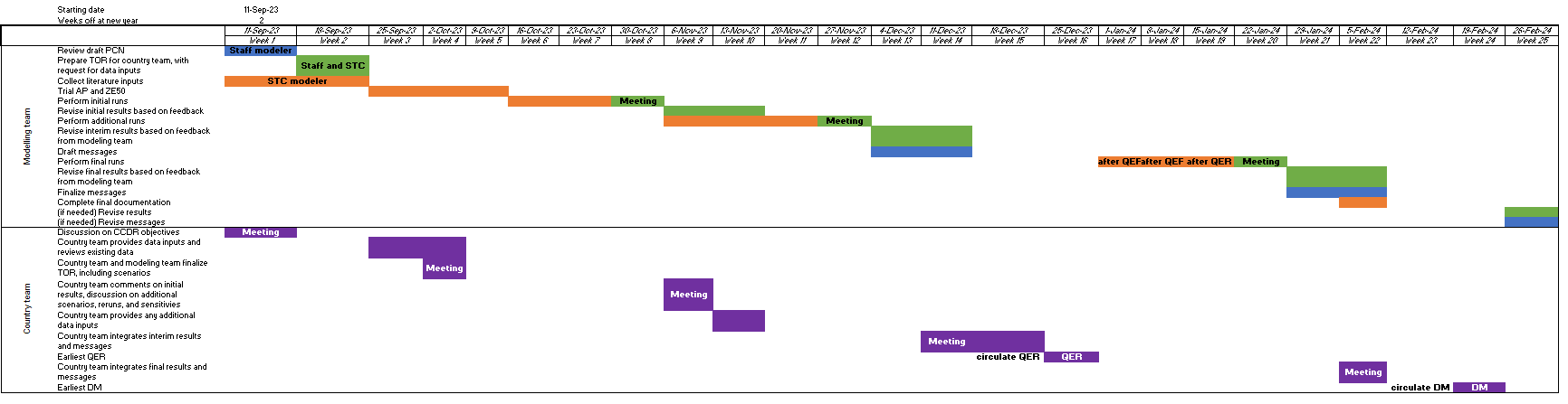

# Annex 5. Estimation of concessional financing needs.

Concessional financing is defined in this note as resources offered at more favorable conditions than those prevailing in regular financial markets.

Reducing power system emissions to zero by a certain target year (e.g., 2050) increases optimal direct power system costs, defined here as the least-cost direct capital and operational expenses in power system expansion and operation, with respect to the same least-cost optimization scenario without taking decarbonization targets or costs of greenhouse gas emissions into account.

The methodology to estimate concessional financing needs is based on affordability of direct power system costs for emerging and developing countries. The approach aims to zero-out the incremental direct costs of power system decarbonization and find the level of concessional finance needed so that the present value of total supply costs is equal in both a scenario without emission constraints and one with emission constraints. To reach this objective, we assume that the participation of concessional financing in the capital structure of firms investing in power system infrastructure can be increased up to a point where the decrease in the present value of annual payments required to amortize investments in capital expenditures exactly matches the incremental costs of decarbonization. A stylized graphic outlining the approach can be found below.

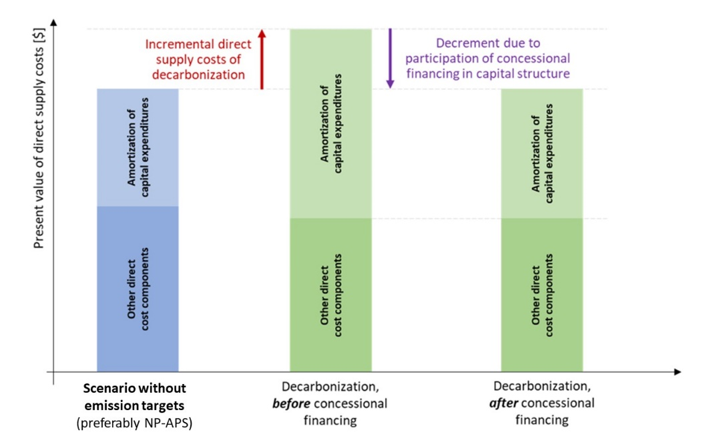

Two variants of this methodology have been developed. Variant 1 assumes that all concessional resources directed to power system investments correspond to debt priced below market rates. Mathematically we are solving:

NPVB = f{ *s*, A**B**[ w*B*(*pB*=0) ], OB } = f{ *s*, A**D**[ wD(*p*) ], OD } = NPVD

Where:

*s* Societal time preference rate

*w WACC*

NPV NPV of total costs

A Sum of annuities for all technologies

O Opex and all costs except capex (which is expressed by annuities)

f Denotes “function of”

p Parcel (%) of concessional financing in the capital structure

d Parcel (%) of debt in capital structure

e Parcel (%) of equity in capital structure

B BAU case

D Decarbonization case

In variant 2, we assume that all concessional resources are grants. Mathematically we are solving:

NPVB = f{ *s*, A**B**[ *g*, w*B*(*pB*=0) ], OB } = f{ *s*, A**D**[ *g,* wD(*p*) ], OD } = NPVD

Where:

g Share (%) of grant in covering investment needs

p Parcel (%) of concessional financing in the capital structure (applies to non-grant investments)

i Denotes an asset

We now have two unknowns: *g* and *p*. In a first approximation we solve for *g* assuming that *p* = 0r.

The annuities for asset *i* are then given by:

$A_{i}=(1-g)∙N_{i}∙\frac{w}{1-{(1+w)}^{T_{i}}}$

Where *Ni* is the *overnight capital cost* of the asset i and *Ti* is the economic lifetime of the asset.

Since (1 – *g*) will be the same for all assets, one can thus take the term out of the equation for each annuity and consider the term as a multiplicative factor for the sum of all annuities.

In both cases, the concessional resources are assumed to displace both non-concessional debt and equity in equal proportions. The exact nature of the concessional resources (low-cost debt *or* grants) will impact by how much each dollar of concessional finance will lower the cost of capital and, consequently, the present value of annual payments required to amortize them.

This simplified methodology has several limitations, including:

* *It assumes that the concessional finance is deployed with the sole goal of zeroing-out the incremental direct costs of decarbonization*. In reality, there are many more reasons to deploy concessional finance. These include using concessional financing to foster economic development, for instance by addressing barriers to investment in infrastructure.
* *It ignores inter-sectoral interactions that affect the need for concessional finance.* In reality, inter-sectoral interactions may impact the need for concessional finance, even if zeroing-out the incremental costs of decarbonization is assumed to be the only goal of financial transfers. The efforts to decarbonize the whole economy will affect local capital markets and change the mix of finance resources across several sectors. This may result, for instance, in relatively low-cost public finance resources that had historically been used in the power sector being redirected to other activities with higher opportunity costs of capital. The resulting increase in costs of capital for the power sector could increase the need for concessional financing.
* *It employs a simplified model of the dynamics of concessional financing.* The impacts of concessional finance can be maximized by using a mix of instruments (grants, low-cost debt, low-cost guarantees, and others) that is adjusted to the specific context of each country and activity. Depending on the risk appetite of donors and the availability of concessional finance, adjusting the mix of instruments to maximize impacts per monetary unit of financial transfer to lenders may involve using resources to reduce residual risks perceived by private capital. These dynamics are not captured by the proposed simplified approach. Furthermore, the approach does not involve a full modeling of cash flows to lenders and investors. It is based on estimates of changes to the weighted average costs of capital (WACC) and on amortization payments.
* *It assumes that concessional resources are used only to finance capital expenditures*. In reality, concessional resources may also be used to fund other types of expenses, including fixed and variable operational expenditures.

The IEEGK team is preparing a blog analyzing initial findings on factors affecting affordability-driven concessional financing needs of different countries seeking power sector decarbonization as a result of past CCDR analyses.

# Annex 6. End of horizon simulation results.

The IEEGK team performed additional simulations with an extended time horizon past 2050 to see if such an extended time horizon under stringent CO2 emission targets such as a net zero by 2050 would remove certain highly uncertain generation technologies from the optimal capacity mix (e.g. CCS).

The IEEGK applied a linear reduction in CO2 emissions from 2025 to 2050 versus the baseline FY22 scenario aiming to reach 100% CO2 emission reduction by 2050 for 3 case studies in Ghana, Morocco and Türkiye. After running the simulation up to 2050, the same run was repeated but the net zero target was extended for a) 5 or 6 more years (so up to 2055 or 2056 depending on whether the model was run in increments of 1 or 2 years) and b) 10 more years (up to 2060). As a result, a minimum of 4 scenarios was run by country (baseline FY22 (BAU); NZ2050; NZ2055 or NZ2056; and NZ2060).

Figure 12 shows the capacity mix for Ghana under the 3 net zero scenario (NZ2050, NZ2056, and NZ2060) in 2040, 2046, and 2050. Figure 13 shows the associated generation mix in the same 3 years. Ghana is a small 5 GW system with mainly gas (60%) and hydro (~40%) in the generation mix.

Figure 12. Capacity mix for Ghana in 2040, 2046, and 2050 upon extending the net zero target to 2056 and 2060. All scenarios constrain the nuclear potential to 2 GW (NuConst) and were run in increments of 2 years.

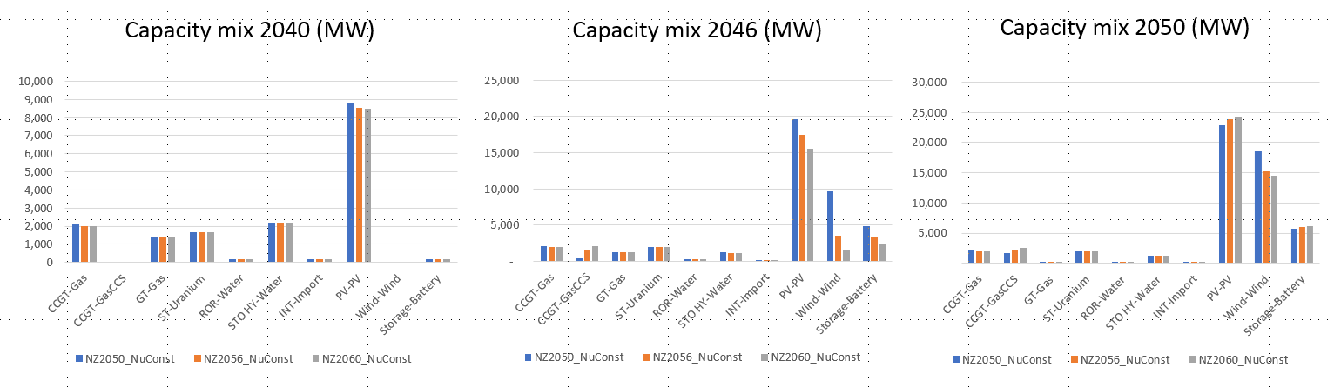

The simulations of these 3 scenarios for Ghana show that in terms of capacity mix:

* Prolonging the modelling horizon brings the deployment of gasCCS forward and slightly increases the deployment of gasCCS by 2050 as the system is able to reap the benefits of CCS’s firmness over a longer period
* Increased deployment of CCS also leads to a shift from the most “firm” RE technology (Wind) to the less “firm” RE technology (solar) together with increased use of battery storage

Figure 13. Generation mix for Ghana in 2040, 2046, and 2050 upon extending the net zero target to 2056 and 2060. All scenarios constrain the nuclear potential to 2 GW (NuConst) and were run in increments of 2 years. 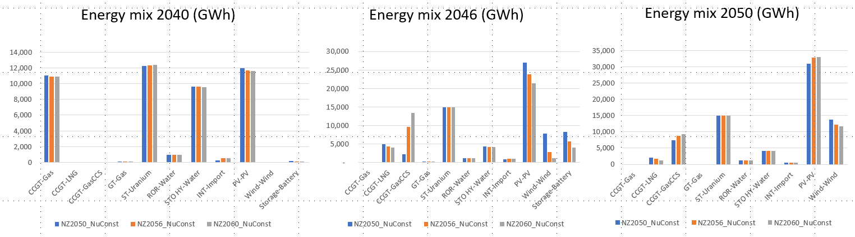

The simulations of these 3 scenarios for Ghana show that in terms of generation mix:

* Faster deployment of GasCCS can lead to an important increase in gasCCS generation at the expense of RE with prolonged modelling horizons, especially in the first years of gasCCS deployment
* The increase in emissions from gasCCS is offset by a decrease in generation from unabated CCGT

Figure 14 and Figure 15 show that important differences can occur in certain years of the last 5 years before 2050 upon extending the modelling horizon but that in 2050 differences between the extended scenarios (NZ2056 and NZ2060) and NZ2050 remain below 12%. The relative sum of absolute differences in 2050 between the NZ2050 and NZ2060 is below 3% both in terms of capacity and energy.

Figure 14. Matrix of differences for capacity mix in Ghana for 2040, 2046, and 2050 upon extended the net zero target to 2056 and 2060. All scenarios constrain the nuclear potential to 2 GW (NuConst).

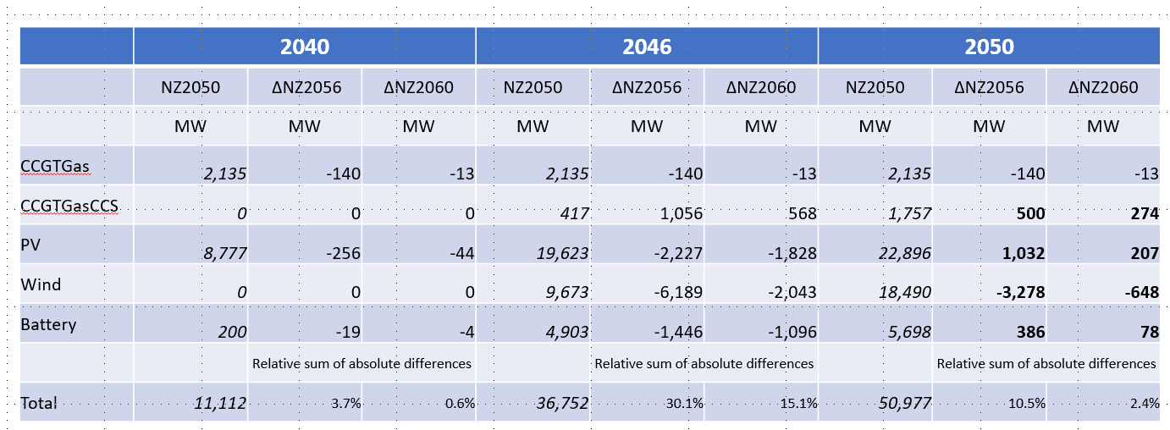

Figure 15. Matrix of differences for generation mix in Ghana for 2040, 2046, and 2050 upon extended the net zero target to 2056 and 2060. All scenarios constrain the nuclear potential to 2 GW (NuConst).

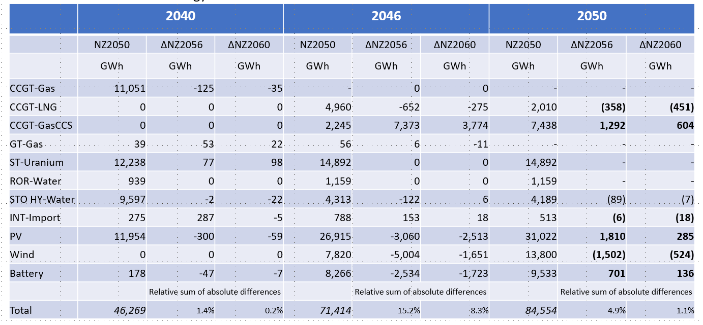

Figure 16 shows the capacity mix for Morocco under the 3 net zero scenario (NZ2050, NZ2055, and NZ2060) in 2040, 2046, and 2050. Figure 17 shows the associated generation mix in the same 3 years. Morocco is another rather small 10 GW system with mainly coal (4 GW), HFO (2 GW), hydro (1.5 GW), gas (~1 GW) and RE (PV, wind, CSP). Generation is dominated by coal (~ 70%). Peak demand is expected to grow from ~ 7 GW in 2022 to 19 GW in 2050.

Figure 16. Capacity mix for Morocco in 2040, 2046, and 2050 upon extending the net zero target to 2056 and 2060. All scenarios were run in increments of 1 year.

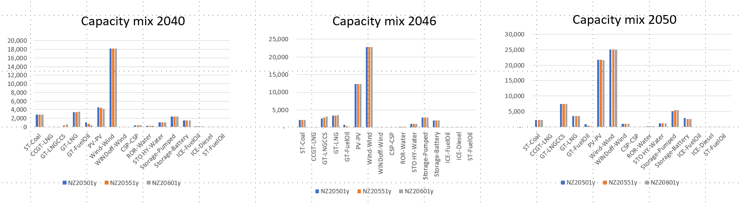

The simulations of these 3 scenarios for Morocco show that in terms of capacity mix:

* Prolonging the modelling horizon leads to earlier deployment of gasCCS as the system is able to reap the benefits of CCS’s firmness over a longer period
* Increased deployment of gasCCS also leads to a decrease in capacity of unabated OCGT (GTFuelOil) and decreased need for storage

Figure 17. Generation mix for Morocco in 2040, 2046, and 2050 upon extending the net zero target to 2056 and 2060.

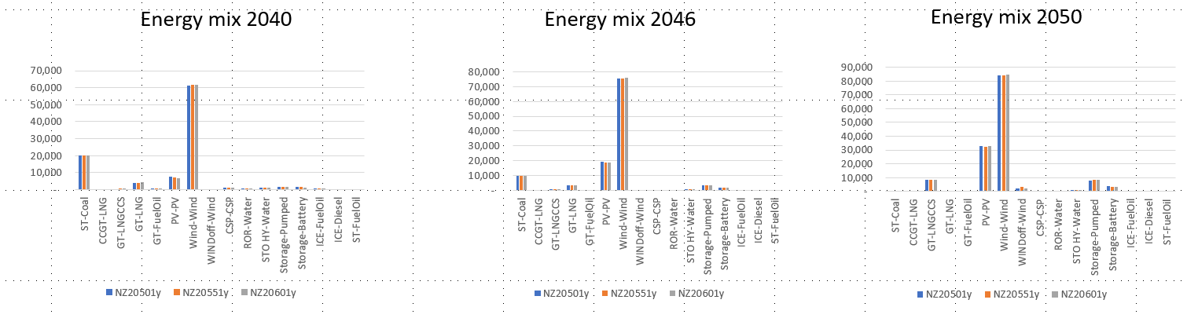

The simulations of these 3 scenarios for Morocco show only minimal changes in generation mix as further evidenced in Figure 17. The relative sum of absolute differences between the NZ2050 scenario on one hand and the extended horizon scenarios (NZ2055 and NZ2060) is always below or equal to 5% both in terms of capacity and energy over the period from 2040 to 2050.

Figure 18. Matrix of differences for capacity mix in Morocco for 2040, 2046, and 2050 upon extended the net zero target to 2055 and 2060.

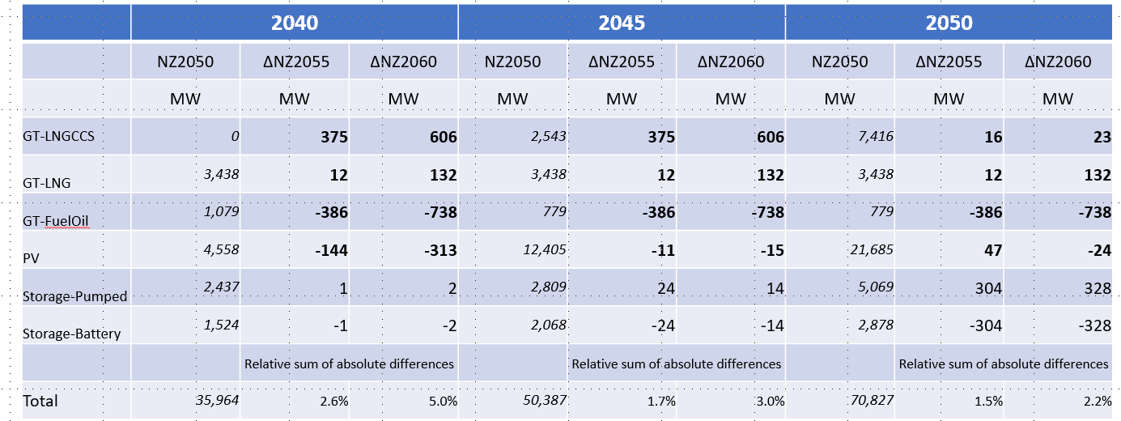

Figure 19. Matrix of differences for generation mix in Morocco for 2040, 2046, and 2050 upon extended the net zero target to 2055 and 2060.

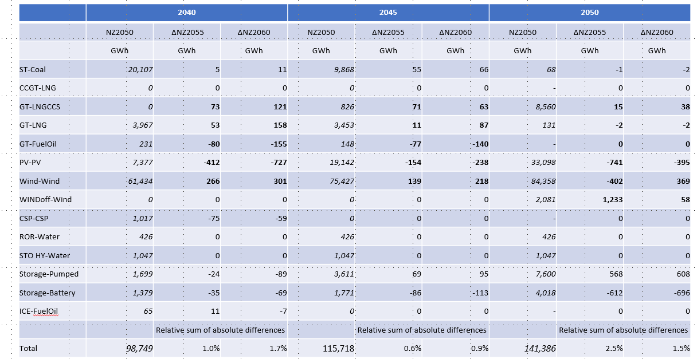

Figure 20 shows the capacity mix for Türkiye under the 3 net zero scenario (NZ2050, NZ2056, and NZ2060) in 2040, 2046, and 2050. Figure 21 shows the associated generation mix in the same 3 years. Turkey is a large power system with an installed capacity of about 100 GW (~ 20 GW of coal; ~ 25 GW of gas; ~ 30 GW of hydro; ~10 GW of PV; ~ 10 GW of wind, and a remainder of geothermal and biomass). The energy mix consists of coal (30%), hydro (30%), gas (15%), and renewables (PV, wind, geo). Peak demand is expected to grow from 52 GW to 110 GW in 2050.

Figure 20. Capacity mix for Türkiye in 2040, 2046, and 2050 upon extending the net zero target to 2056 and 2060. All scenarios were run in increments of 2 years.

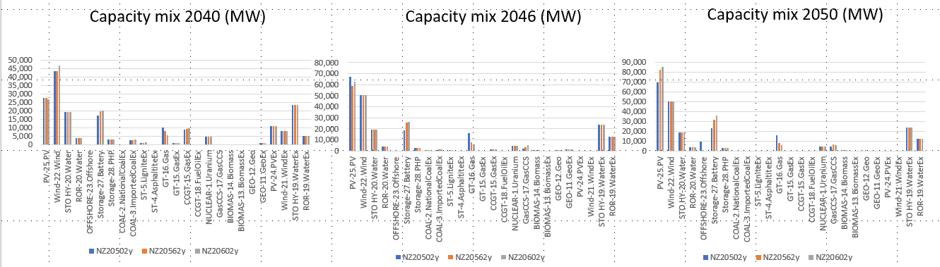

The simulations of these 3 scenarios for Türkiye show that in terms of capacity mix:

* Prolonging the modelling horizon leads to increasing deployment of gasCCS as the system is able to reap the benefits of CCS’s firmness over a longer period
* Increased deployment of low capex renewables (solar PV) with BESS by 2050 with a simultaneous decrease in deployment of high capex renewables (wind offshore) upon prolonging the modelling horizon
* Increased deployment of low capex renewables + BESS and gasCCS also leads to a decrease in capacity of unabated OCGT (GTFuelOil) by 2050

Figure 21. Generation mix for Türkiye in 2040, 2046, and 2050 upon extending the net zero target to 2056 and 2060.

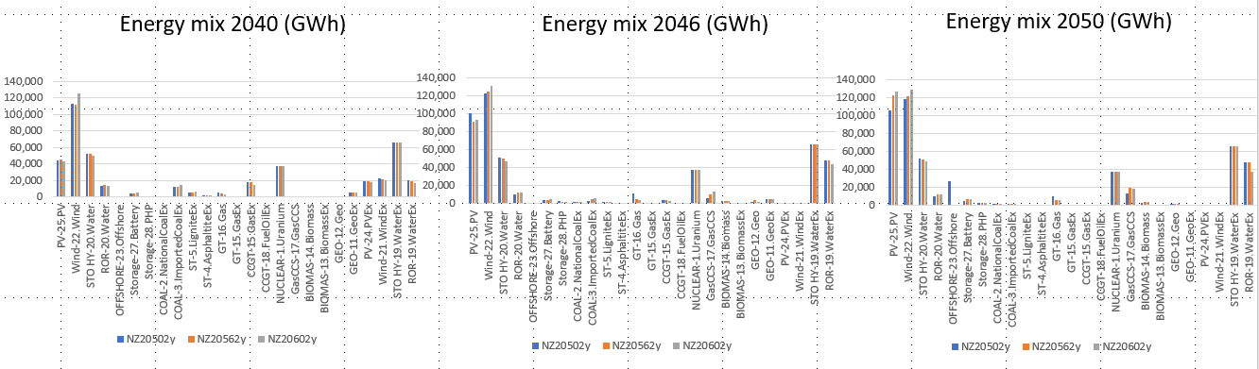

The simulations of these 3 scenarios for Türkiye show the following trends in terms of generation mix:

* Increased generation from low cost RE (solar PV and wind) together with a decrease in generation from higher capex RE (wind offshore) upon extension of modelling horizon
* Increased use of gasCCS and RE generation + BESS reduces the need for unabated gas generation by 2050

The simulations of these 3 scenarios for Türkiye show only important differences both in capacity and generation mix as further evidenced in Figure 22 and Figure 23. The relative sum of absolute differences between the NZ2050 scenario on one hand and the extended horizon scenarios (NZ2055 and NZ2060) is often above 10% both in terms of capacity and energy over the period from 2040 to 2050.

Figure 22. Matrix of differences for capacity mix in Türkiye for 2040, 2046, and 2050 upon extended the net zero target to 2056 and 2060.

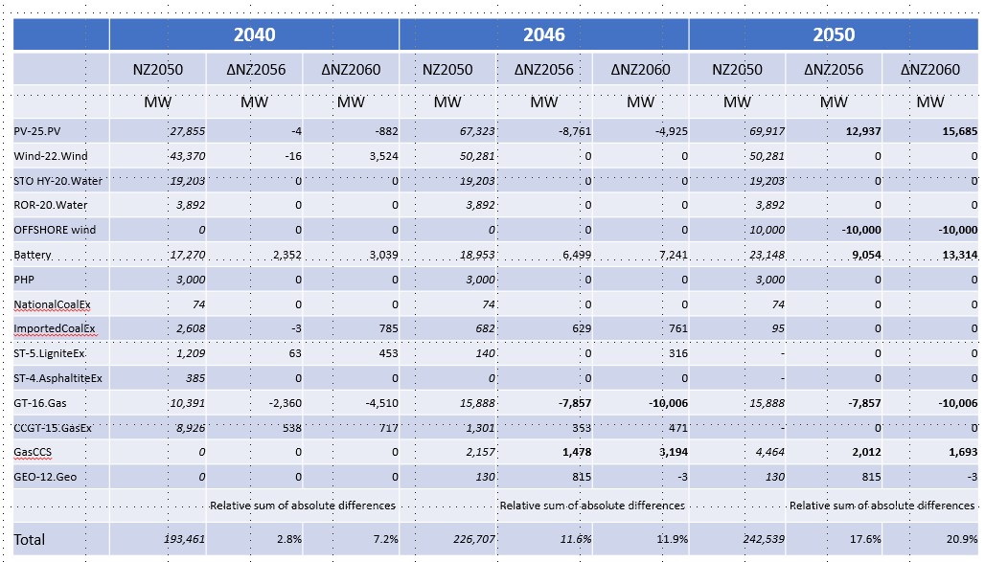

Figure 23. Matrix of differences for generation mix in Türkiye for 2040, 2046, and 2050 upon extended the net zero target to 2056 and 2060.

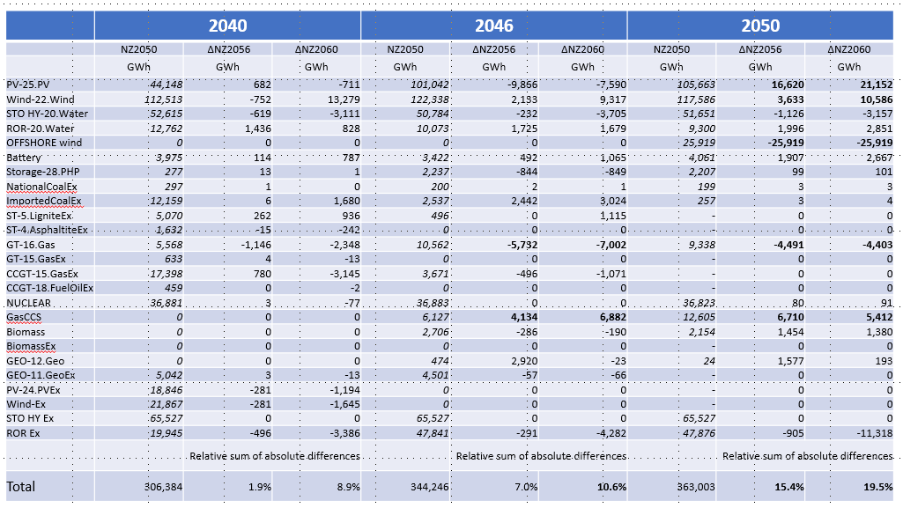

These end of horizon simulations with an extended modelling horizon keeping the net zero emission target for 5 (or 6) and 10 more years demonstrate that:

* GasCCS keeps being part of the optimal capacity plan for deep power sector decarbonization in Ghana, Morocco, and Türkiye under the current set of assumptions even if we extend the modelling horizon up to 10 years (up to 2060) while keeping the same emission target as for 2050 in the scenarios with an extended modelling horizon. For Ghana, gasCCS remains part of the optimal capacity plan even with 3 GW of nuclear candidate capacity!
* Extension of the modelling horizon does not lead to very large changes in the capacity or generation mix for the smaller systems of Ghana and Morocco. The simulations indicate only a very small increase in gasCCS in the capacity plan and generation mix upon horizon extension.
* However, for the larger Türkiyesystem there are significant differences in the optimal VRE + BESS capacity expansion plan leading to lower needs for unabated gas by 2050

Therefore, the recommendation will be to run upcoming energy transition simulations up to 2060 especially for larger systems. In case of time constraints, modelling teams should only revert to a modelling horizon up to 2050 for smaller systems where we know that the impacts of end of horizon issues are much smaller.

# Annex 7. Discount rate calculation using WB guidelines.

According to the most recent WB guidelines on selecting the discount rate [45], the discount rate r should be calculated using the Ramsey rule:

$$r= δ+γ*g$$

With: δ: the pure rate of time preference which must be set to zero.

γ: the marginal utility of consumption. Literature estimates vary between 1 and 2. A recommended default value is 2

g: the long-term average GDP per capita growth rate. The long-term GDP per capita growth rate can be estimated from the GDP (at purchasing power prices) growth rate and the population projections from the latest IMF World Economic Outlook.

Task teams are encouraged to use a minimum societal time preference rate of 6%. In case the above equation results in a value lower than 6%, task teams should check if a value above 2 is warranted for γ in the country under investigation.

# Annex 8. Representative days analysis.

The IEEGK team performed an analysis on the selection of an optimal set of representative days that approximates the load duration curve as close as possible while also preserving the correlation between the power system load and VRE resource (PV and wind) availability. Two types of methods were analyzed:

* k-means clustering
* An optimization method as described by Poncelet et al. [1]

*K-means clustering*

K-means clustering partitions n observations into k clusters in which each observation belongs to the cluster with the nearest centroid, which is defined as the element-wise mean of all observations belonging to that cluster:

$${centroid}_{k}=\frac{sum (assignment_{i,k } × p_{i})}{n_{k}}$$

where assignment ti,k is one if observation i belongs to cluster k and is zero otherwise; pi is the value of observation i; and nk is number of observations belonging to cluster k.

First, we randomly assign all observations to a cluster and the initial centroids are calculated. Afterwards observations are reassigned to the closest cluster in terms of smallest Euclidean distance to each of the cluster centroids. This makes another round of centroid calculation possible, and the reassignment process is repeated until convergence (no reassignment is reached).

In our analysis we tested the k-means algorithm on a sample of duration curves (relative load vs. yearly peak load, PV CF, and onshore wind CF) from 7 Western Africa Power Pool (WAPP) countries (Burkina Faso, Senegal, Ivory Coast, Ghana, Mali, Niger, and Nigeria). The aim was to find the optimal number of representative days per season. We used both the k-means clustering algorithm AS IS as well as the k-closest days method where the resulting centroids from the k-means clustering algorithm are replaced by the real day for which the duration curves’ values are closest to the calculated centroids.

We compared the performance of the clustering algorithms in terms of relative average error, normalized root mean square error (NRMSE), relative maximum peak error [(calculated relative peak – observed relative peak)/observed relative peak], and average absolute correlation error. We started by treating all days as non-specials days and progressively add special days (max load day, max PV day, min PV day, max wind day, min wind day).

As expected, an increasing number of clusters lowers the NRMSE. The closest days algorithm results in lower NRMSE (Figure 24) and typically better preserves the correlations (Figure 25), except for the correlation between load and PV with 4 and 6 clusters.

Figure 24 Comparison of NRMSE in terms of load, PV, and Wind profiles for k-means centroid and k-closest days algorithms.

|  |  |  |
| --- | --- | --- |
|  |  |  |

Figure 25 Comparison of correlation errors in terms of load-PV, load-wind, and PV-Wind profiles for k-means centroid and k-closest days algorithms.

|  |  |  |
| --- | --- | --- |
|  |  |  |

Afterwards the analysis compared the performance of the following 4 combinations of representative days which included different types of special days:

* Max load day with 6 clusters (type 1)
* Max load day, min wind, min solar with 4 clusters (type 2)
* Max load day, min wind, min solar, max wind and max solar with 2 representative days (type 3a)
* Max load day, min wind, min solar, max wind and max solar with 4 representative days (type 3b)
* 6 clusters with no special days

The special days are defined as follows. The max load day is the day in a season for which the hourly load in that season in maximal. The minimum and maximum solar days in a season are the days for which the sum of the daily solar capacity factors is minimal or maximal respectively. The minimum and maximum wind days in a season are the days for which the sum of the daily wind capacity factors is minimal or maximal respectively.

Overall the type 2 and type 3b combinates seem to be the best combinations (Figure 26 and Figure 27) given their low RMSE for load an either wind (type 2) or PV (type 3b), close approximation of peak load, and rather low correlation error (especially for loadWind and LoadPV).

Figure 26 Comparison of NRMSE in terms of load, PV, and Wind profiles, and relative maximum peak error for k-means centroid and k-closest days algorithms (SD = special days).

|  |  |  |  |
| --- | --- | --- | --- |
|  |  |  | |
|  |  |  |

Figure 27 Comparison of correlation errors in terms of load-PV, load-wind, and PV-Wind profiles for k-means centroid and k-closest days algorithms (SD = special days).

|  |  |  |
| --- | --- | --- |
|  |  |  |

*The Poncelet et al. algorithm*

In this algorithm, the aim is to minimize the difference calculated duration curves and the observed duration curves (Figure 28). The duration curves include load, PV, Wind, the correlation between load and PV, the correlation between load and wind, and the correlation between PV and wind. The correlation duration curve is defined using the equation below:

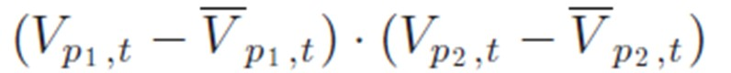

Figure 28 Poncelet et al. algorithm.

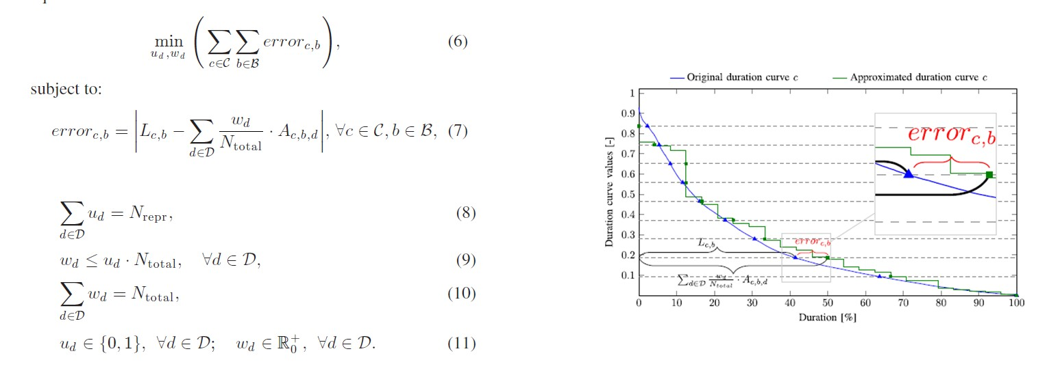

The Poncelet et al. optimization method performs better in terms of NRMSE for load and PV (Figure 29) and also better preserves the correlations between load and VRE resource availability (Figure 30) than the k-closest days algorithm for the 4 selected combinations of representative days.

Figure 29 Comparison of NRMSE in terms of load, PV, and Wind profiles for k-closest days algorithm and Poncelet optimization.

|  |  |  |
| --- | --- | --- |
|  |  |  |

Figure 30 Comparison of correlation errors in terms of load-PV, load-wind, and PV-Wind profiles for k-closest days algorithm and Poncelet optimization .

|  |  |  |
| --- | --- | --- |
|  |  |  |

*A real power system case – Ivory Coast*

In this example we compared the performance of different combinations of representative days with respect to the case where we run each hour (8760 hour) of a year. We first run an 8760 hours per year simulation in increments of 2 years for the 2022-2040 period for an National Policies in APS World scenario. Afterwards we rerun the simulation for the following combinations of representative days:

* Case 1: Max load day, min wind, min solar with 4 representative days using k-closest days
* Case 2: Max load day, min wind, min solar with 4 representative days using the Poncelet optimization method
* Case 3: Max load day, min wind, min solar, max wind and max solar with 4 representative days using k-closest days
* Case 4: Max load day, min wind, min solar, max wind and max solar with 4 representative days using the Poncelet optimization method
* Case 5: Max load day with 6 representative days using k-closest days

The Ivory Coast power system is currently dominated by gas and hydro (Figure 31).

Figure 31 Existing capacity by type in Ivory Coast.

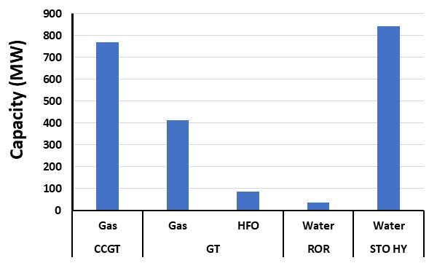

The cases 1 (max load day, min wind, min solar with 4 representative days using k-closest days),2 (max load day, min wind, min solar with 4 representative days using the Poncelet optimization method), and 4 (max load day, min wind, min solar, max wind and max solar with 4 representative days using the Poncelet optimization method) give the best approximation of the total system costs (NPV) as compared to the 8760 case.

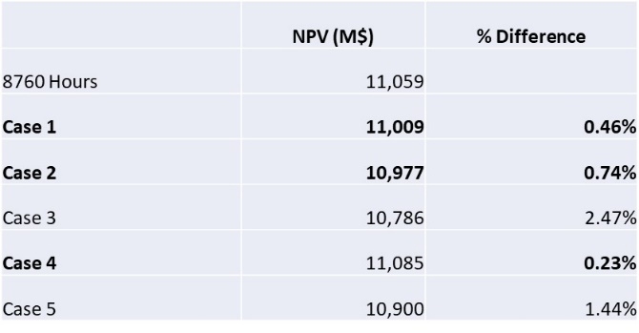

In terms of capacity mix Case 1, 2, and 4 closely match the final (2040) capacity mix of the 8760 case. Case 4 most closely matches the capacity plan in terms of firm capacity (gas and coal) of the 8760 case (Figure 32). Cases 2 and 4 also closely match the 2040 generation mix of the 8760 case (Figure 33).

Figure 32 Comparison of 8760 case with representative days cases in terms of capacity mix for Ivory Coast (National Policies in APS World scenario).

|  |  |
| --- | --- |
|  |  |

Figure 33 Comparison of 8760 case with representative days cases in terms of generation mix for Ivory Coast (National Policies in APS World scenario).

|  |  |
| --- | --- |
|  |  |

Afterwards we repeated the same exercise but in a power decarbonization 2050 scenario. All cases with combinations of representative days are within 2.5% of the 8760 case in terms of NPV with cases 1, 2, and 4 best approximating the 8760 NPV.

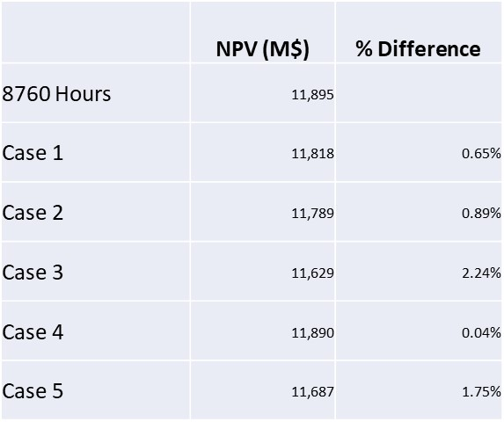

Cases 2 and 4 most closely match the required firm capacity as for the 8760 case over time (Figure 34).

Figure 34 Comparison of 8760 case with representative days cases in terms of capacity mix for Ivory Coast (power decarbonization 2050 scenario).

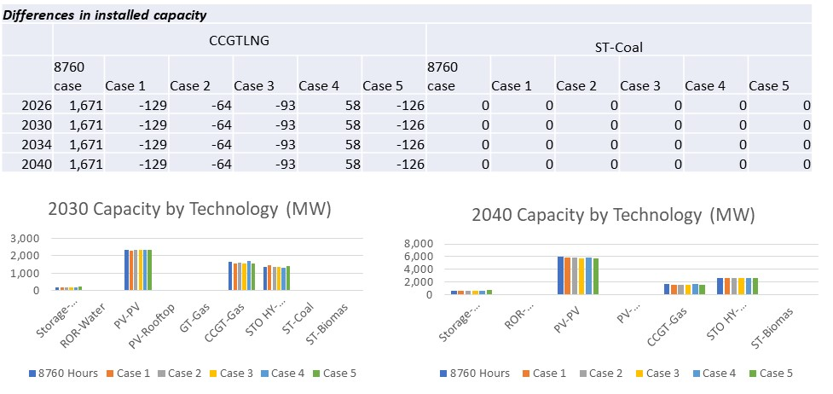

*A second real power system case – Morocco*

We repeat the same analysis as for Ivory Coast for Morocco using the same combinations of representative days. Morocco is a more balanced power system than Ivory Coast with about 10 GW of installed capacity consisting of mainly coal (4 GW), HFO (2 GW), hydro (1.5 GW), gas (~1 GW) and RE (PV, wind, CSP). Generation is dominated by coal (~ 70%). Peak demand is expected to grow from ~ 7 GW in 2022 to 19 GW in 2050.

For an National Policies in APS World scenario all cases with combinations of representative days are within 3.0% of the NPV of the 8760 case. Cases 1 and 2 most closely match the required firm capacity (gas, coal and storage) as obtained in the 8760 case (Figure 35).

Afterwards we repeated the same exercise but in a power decarbonization 2050 scenario. All cases with combinations of representative days are within 3.0% of the 8760 case in terms of NPV with cases and 2, best approximating the required firm capacity as obtained in the 8760 case (Figure 36).

Figure 35 Comparison of 8760 case with representative days cases in terms of capacity mix for Morocco (National Policies in APS World scenario).

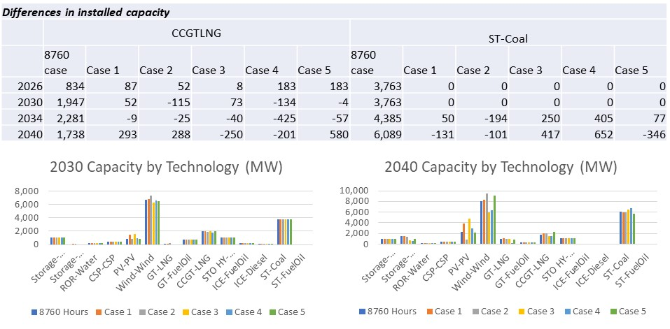

Figure 36 Comparison of 8760 case with representative days cases in terms of capacity mix for Morocco (power decarbonization 2050 scenario).

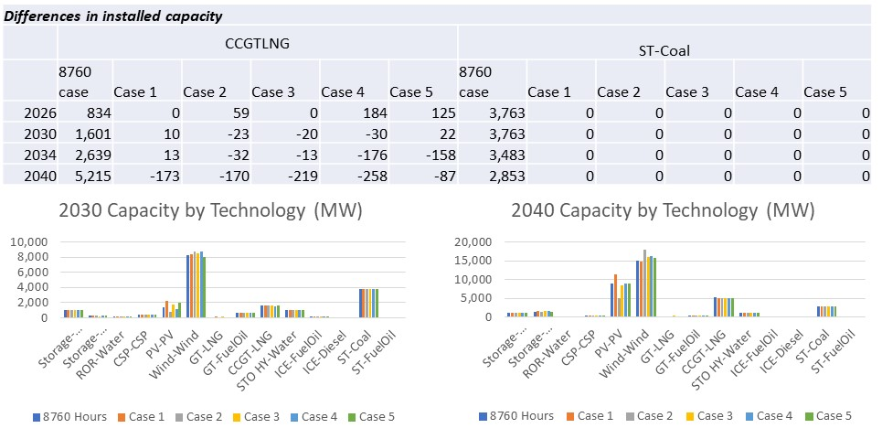

*Conclusion*

The cases with a total of 7 representative days (max load day, min wind day, min solar day and 4 additional representative days) often yield similar or even better performance than the cases with 9 representative days (max load day, min wind day, min solar day, max wind day and max solar day with 4 additional representative days) both in terms of calculating the “true” NPV (as obtained in the 8760 case) and the required firm capacity

Therefore, the recommendation is to use a model with 7 representative days (max load day, min wind day, min solar day and 4 additional representative days)

In terms of the choice between the k-means and the Poncelet algorithm with 7 representative days, our preference goes to the Poncelet optimization algorithm since it:

* + Predicts the “true” NPV better in the Morocco case (and Morocco has a more “balanced” power system with coal/hydro/gas/VRE than Ivory Coast which is mainly gas/hydro)
  + Better forecasts the necessary firm capacity

# References

|  |  |
| --- | --- |
| [1] | K. Poncelet, H. Hoschle, E. Delarue, A. Virag and W. D'haeseleer, "Selecting Representative Days for Capturing the Implications of Integrating Intermittent Renewables in Generation Expansion Planning Problems," *IEEE Transactions on Power Systems,* vol. 32, no. 3, pp. 1936-1948, 2017. |
| [2] | ESMAP, "https://esmap.org/esmap_offshorewind_techpotential_analysis_maps," ESMAP, [Online]. Available: https://esmap.org/esmap_offshorewind_techpotential_analysis_maps. |
| [3] | ESMAP and University of California Santa Barbara's (UCSB) , "https://rezoning.energydata.info/," [Online]. |
| [4] | World Bank, "Economic Analysis of Battery Energy Storage Systems," World Bank, Washington DC, 2020. |
| [5] | T. Remy and D. Chattopadhyay, "Enhancing dispatch efficiency of the Nigerian power system: Assessment of benefits," *Energy for Sustainable Development,* vol. 62, pp. 29-43, 2021. |
| [6] | J. Gilmore, T. Nolan and P. Simshauser, "The Levelised Cost of Frequency Control Ancillary Services in Australia’s National Electricity Market," *EPRG,* 2022. |
| [7] | IEA, "Projected Costs of Generating Electricity, 2020," 2020. |
| [8] | IRENA, "Renewable Power Generation Costs 2021," 2022. |
| [9] | NREL, "NREL Annual Technology Baseline 2023," NREL, 2023. [Online]. Available: https://atb.nrel.gov/electricity/2023/data. |
| [10] | IEA, "World Energy Model - Techno-economic inputs," IEA, 2021. [Online]. Available: https://www.iea.org/reports/world-energy-model/techno-economic-inputs. [Accessed 26 August 2022]. |
| [11] | EIA, "Cost and Performance Characteristics of New Generating Technologies, Annual Energy Outlook 2022," EIA, 2022. [Online]. Available: https://www.eia.gov/analysis/studies/powerplants/capitalcost/. [Accessed 26 August 2022]. |
| [12] | Pacific Northwest National Laboratory, "Energy Storage Technology and Cost Characterization Report," 2019. |
| [13] | International Forum on Pumped Storage Hydropower, "Pumped Storage Hydropower Capabilities and Costs," 2021. |
| [14] | IEA, "World Energy Outlook 2022," IEA, Paris, 2022. |
| [15] | IEA, "Energy Technology Perspectives 2020 - Special Report on Carbon Capture Utilisation and Storage," IEA, Paris, 2020. |
| [16] | Global CCS Institute, "Technology Readiness and Costs of CCS," 2021. |
| [17] | IEA, "Retrofitting CO2 capture to existing power plants," IEA, Paris, 2011. |
| [18] | NETL, "COST AND PERFORMANCE OF RETROFITTING NGCC UNITS FOR CARBON CAPTURE," 2013. |
| [19] | S. Roussanaly, N. Berghout, T. Fout, M. Garcia, S. Gardarsdottir, S. Nazir, A. Ramirez and E. Rubin, "Towards improved cost evaluation of Carbon Capture and Storage from Industry," *International Journal of Greenhouse Gas Control,* vol. 106, 2021. |
| [20] | IRENA, "Flexibility in Conventional Power Plants," IRENA, Abu Dhabi, 2019. |
| [21] | Agora Energiewende, "Flexibility in thermal power plants," 2017. |
| [22] | E. Kaushik, V. Prakash, O. Mahela, B. Khan, A. El-Shahat and A. Abdelaziz, "Comprehensive Overview of Power System Flexibility during the Scenario of High Penetration of Renewable Energy in Utility Grid," *Energies,* vol. 15, no. 2, 2022. |
| [23] | A. Peakman, B. Merk and K. Hesketh, "The Potential of Pressurised Water Reactors to Provide Flexible Response in Future Electricity Grids," *Energies,* vol. 13, 2020. |
| [24] | Aurecon, "2020 Costs and Technical Parameter Review. Consultation Report for Australian Energy Market Operator (AEMO)," 2020. |
| [25] | LeighFischer , "Electricity Generation Costs and Hurdle Rates," 2016. |
| [26] | U.S. Department of Energy , "U.S. Hydropower Market Report - January 2021," 2021. |
| [27] | ESMAP, "Global Solar Atlas," ESMAP, [Online]. Available: https://globalsolaratlas.info/. [Accessed 26 August 2022]. |
| [28] | "Renewables ninja," [Online]. Available: https://www.renewables.ninja/. [Accessed 26 August 2022]. |
| [29] | T. Yunus Khan, M. Soudagar, M. Kanchan, A. Afzal, N. Banapurmath, N. Akram, S. Mane and K. Shahapurkar, "Optimum location and influence of tilt angle on performance of solar," *Journal of Thermal Analysis and Calorimetry,* vol. 141, pp. 511-532, 2019. |
| [30] | ESMAP, "Global Wind Atlas," ESMAP, [Online]. Available: https://globalwindatlas.info/. [Accessed 26 August 2022]. |
| [31] | NREL, "https://www.re-explorer.org/," [Online]. Available: https://www.re-explorer.org/. [Accessed 26 August 2022]. |
| [32] | E3 Consult, "Social and economic drivers for hydropower development in Danube countries," 2020. |
| [33] | F. Kahrl, J. Lin, X. Liu and J. Hu, "Sunsetting coal power in China," *iScience,* vol. 24, no. 9, 2021. |
| [34] | S. Garcia-Freites, C. Gough and M. Roder, "The greenhouse gas removal potential of bioenergy with carbon capture and storage (BECCS) to support the UK’s net-zero emission target," *Biomass and Bioenergy,* vol. 151, 2021. |
| [35] | International CCS Knowledge Centre, "Approaching Negative Greenhouse Gas Emissions via Bioenergy with CO 2 Capture and Storage In Saskatchewan," 2019. |
| [36] | C. Donnison, R. Holland, L.-M. Armstrong, F. Elgenbrod and G. Taylor, "Bioenergy with Carbon Capture and Storage (BECCS): Finding the win–wins for energy, negative emissions and ecosystem services—size matters," *GCB Bionenergy,* vol. 12, pp. 586-604, 2020. |
| [37] | WB, "Guidance Manual: Greenhouse Gas Accounting for Energy Investment Operations," WB, Washington D.C., 2015. |
| [38] | IPCC, "IPCC Guidelines for National Greenhouse Gas Inventories," 2006. |
| [39] | M. Fasihi, O. Efimova and C. Breyer, "Techno-economic assessment of CO2 direct air capture plants," *Journal of Cleaner Production,* vol. 224, pp. 957-980, 2019. |
| [40] | T. Nikolakakis, D. Bozkir, D. Chattopadhyay and A. Merino, "Analysis of Long-term Variable Renewable Energy Heavy Capacity Plans Including Electric Vehicle and Hydrogen Scenarios: Methodology and Illustrative Case for Turkey," *IEEE Access,* 2022 (forthcoming). |
| [41] | IEA, "Global EV Outlook 2020," IEA/OECD, Paris, 2020. |
| [42] | C. M. Briceno-Garmendia, W. Qiao and V. Foster, "The Economics of Electric Vehicles for Passenger Transportation," World Bank, 2022. |
| [43] | A. Mastrucci, B. v. Ruijven, E. Byers and M. Poblete‑Cazenave, "Global scenarios of residential heating and cooling energy," *Climate Change,* 2021. |
| [44] | World Energy Council, "Working Paper Hydrogen demand and cost dynamics," 2021. |
| [45] | Joint Research Centre (JRC), "Historical Analysis of FCH 2 JU Electrolyser Projects," JRC, Luxembourg, 2021. |
| [46] | A. Christensen, "Assessment of Hydrogen Production Costs from Electrolysis: United States and Europe," 2020. |
| [47] | IEA, "Global Hydrogen Review," 2022. |
| [48] | WB, "WB Guidelines on Discount Rate," 2016. |
| [49] | IEA, "World Energy Outlook 2021," IEA, 2021. |
| [50] | S. Pfenninger, "Dealing with multiple decades of hourly wind and PV time series inenergy models: A comparison of methods to reduce time resolution and the planning implications of inter-annual variability," *Applied Energy,* vol. 197, pp. 1-13, 2017. |
| [51] | W. Bank, "Economic Analysis for Project Appraisal of Battery Energy Storage Systems," World Bank, Washington D.C., 2020. |
| [52] | WB, "INTERIM TECHNICAL NOTE Greenhouse Gases from Reservoirs Caused by Biochemical Processes," WB, Washington D.C., 2013. |
| [53] | National Hydropower Association, "2021 Pumped Storage Report," 2021. |

1. Authors: Tom REMY ([tremy@worldbank.org](mailto:tremy@worldbank.org)) and Raimund MALISCHEK (rmalischek@worldbank.org).
2. This note is a work in process and the IEEGK team will update Annex 3 over the coming months.
3. The National Policies in APS World scenario considers economic costs (i.e., net of taxes and subsidies) and does not account for financial contracts (e.g., take or pay clauses, agreed power purchase prices, etc.).
4. As a result, from the definition of actionable policies, country NDCs or adaptation policies may or may not be part of the actionable policies scenario.
5. This forecast preferably aligns with inputs from the WB macro fiscal team in terms of forecasted GDP growth.
6. This is the total electricity need (in GWh). The total electricity need accounts both for consumption from customers connected to the grid and technical losses to transport the electricity from the generator terminals to the customers.
7. In the absence of historic hourly load data, task teams can take the load factor from a recent year in a worst-case scenario.
8. For the avoidance of doubt, the load profile is the gross load profile (i.e., before subtracting the electricity provided by non-dispatchable resources such as wind and solar).
9. With only modest changes in load factor (e.g., less than 10 percentage points over the modelling horizon), task team can allow a typical power system model such as EPM to endogenously recalculate the load profile in a given year based on the original load profile and the projected gross electricity generation. In such cases modelers do not need to explicitly recalculate the entire load profile for each year of the modelling horizon.
10. Periods of 1 year are preferred but computational time limitations could force modelling teams to choose time periods of 2 years.
11. The recommendation is to use the solar profile (and wind) profile from the highest capacity factor tranch in case tranching of VRE potential is used (see section 3.2.3.2). This recommendation holds unless the potential of the highest capacity factor tranch is very small (e.g. less than 5% of the peak demand by 2050), in which case it is advisable to use the profile from the second highest capacity factor tranch.
12. Specific candidate plants are candidate plants listed by name and associated COD in a recent reputable data source.
13. Unless a country has significant biomass power development plants, CCDR energy teams should use conservative estimates of the biomass energy potential (MJ/year). Biomass potential in MW can be obtained from the biomass energy potential by dividing the biomass energy potential by a default heat rate (*Table 6*) and a typical technical availability of 70%.
14. Initial refers to the cost base year on which all real costs (USD YYYY where YYYY is the cost base year) will be referenced to. Unless otherwise stated all costs use 2022 as cost base year and thus all listed costs are in USD 2022.
15. Note that the current version of EPM only allows for decreases in overnight capital costs. Other costs are assumed to remain constant over the modelling horizon in EPM.
16. The presented capital cost trajectories show the IEA WEO2022 APS scenario data for utility PV, wind onshore and wind offshore. Since the IEA WEO2022 scenario only contains CAPEX trajectories for the EU, USA, India and China, the recommendation is to use one average trajectory for both IBRD and IDA countries. In addition, IEA WEO2022 does not list CAPEX trajectories for rooftop PV, CCS technologies, hydro, CSP, geothermal, biomass, and storage. Therefore, the recommended CAPEX trajectories for rooftop PV, CCS technologies, geothermal, CSP, biomass and storage come from the NREL ATB moderate forecast.
17. For generic future CCGT plants, task teams should preferably define green hydrogen as a secondary fuel.
18. For generic future OCGT plants, task teams should preferably define green hydrogen as a secondary fuel.
19. For existing plants, the input starting year of operation should be interpreted as the maximum of the first year of commercial operation and the year in which the latest major overhaul took place. In case a major overhaul took place recently, the CAPEX of the plant should be the overnight capital cost of the overhaul and not the initial capital cost to bring the plant into commercial operation.
20. Unit size is especially relevant to determine the largest unit in the power system which in turn influences the required amount of spinning reserve in the system. Specifically for EPM, the required spinning reserve is calculated as the sum of the size of the largest unit in the power system and a maximum forecast error (typically 20 percent) on the generation from VRE resources (wind and solar).
21. EPM allows to endogenously optimize the number of hours of storage for batteries. In case the modelling tool does not allow such feature, the recommendation is to at least allow batteries with 2, 4 and 6 hours of storage as candidate plants.
22. Pumped storage hydro plants can have a wide range of expected storage capacity (hours of storage), typically in the range of 6 – 50 hours of storage. A recommended default value is 12 hours of storage in the absence of site specific information [50].
23. The maximum technical availability accounts both for unplanned maintenance (forced outages) and planned maintenance (planned outages), except for the hydro, wind, solar, and biomass generators. For these hydro, wind, solar, and biomass generators, the model assumes that planned outages occur outside the operating hours of the plant.
24. For more info on the models to calculate the hourly profiles see Pfenninger et al. [47] or the documentation available on the website (https://www.renewables.ninja/about).
25. From a sample of the 10 most popular turbines in the UK, this is the efficient turbine. It has the highest capacity factor across different selected sites in former modelling exercises. We chose the UK as a reference here since a) data about the deployment of different wind turbine types is readily available and b) wind power provides a large share of the UK’s electricity generation mix (over 20% in 2020).
26. Tutorial videos are available here: https://rezoning.energydata.info/about
27. The recommendation is to not include any constraints in terms of solar radiation (kWh/m2/day), elevation (m), population density (people per km2), distance to transmission lines (km), distance to roads (km), distance to airports (km), and distance to UNESCO World Heritage sites (km).
28. Tutorial videos are available here: https://rezoning.energydata.info/about
29. The recommendation is to not include any constraints in terms of maximum wind speed at 100m (m/s), elevation (m), population density (people per km2), distance to transmission lines (km), distance to roads (km), distance to airports (km), and distance to UNESCO World Heritage sites (km).
30. In general wind profiles across different zones in a country tend to show larger variations than solar profiles.
31. The capacity credit is the proportion of the available plant capacity that can be reliably expected to generate

    electricity during times of peak demand in the grid to which the plant is connected.
32. Note that we make the simplification that CC values do not change with increased penetration of variable renewable generators. The choice for rather conservative default CC values already offset a large part of this potential decrease in CC values since we use rather low CC values throughout the modelling horizon.
33. In case no specific plans exist for new high voltage transmission lines, the earliest deployment date for such lines is 2027.
34. For additional details see the World Bank Interim Technical Note for GHG from Reservoirs Caused by Biochemical Processes (<https://openknowledge.worldbank.org/handle/10986/16535>) [49].
35. The WACC is needed as an input to calculate the annuities of the CAPEX outlays for investment in new generation assets.
36. IEEGK team can provide the detailed calculation method for parameters A and B if requested.
37. Country risk premia can be based on the JP Morgan EMBI index or the latest country risk premia published by Professor A. Damodaran from Stern School of Business at New York University (https://pages.stern.nyu.edu/~adamodar/New_Home_Page/datafile/ctryprem.html).
38. This is an approximation where we make abstraction of the potential need of the power system to lower the output of thermal plants (so-called “lowering reserve”) because of the increased output of variable renewable resources.
39. If time permits, modelling teams can run an optimistic DAC scenario with a levelized DAC cost of 140 USD per ton CO2.
40. The presented capital cost trajectories show the IEA WEO2022 STEPS scenario data for utility PV, wind onshore and wind offshore. Since the IEA WEO2022 scenario only contains CAPEX trajectories for the EU, USA, India and China, the recommendation is to use one average trajectory for both IBRD and IDA countries. In addition, IEA WEO2022 does not list CAPEX trajectories for rooftop PV, CCS technologies, hydro, CSP, geothermal, biomass, and storage. Therefore, the recommended CAPEX trajectories for rooftop PV, CCS technologies, geothermal, CSP, biomass and storage come from the NREL moderate forecast.
41. Note that not all potential applications for electrification of the sectors are included in the sections below. Other applications could be considered given specific country contexts and future versions of this note will try to expand to include further applications.
42. Modelling teams should also always run a scenario where the demand in the PD2050-NZE scenario is the same as for the Actionable Policies scenario for comparison purposes across energy transition analyses.
43. The IEEGK team has prepared a note summarizing the key messages on the role of hydrogen in the energy transition.
44. If the tasks teams run a scenario where the zero emissions target year is 2060, then the modelling horizon should be extended to 2070.
45. The IEEGK team is also preparing guidelines to estimate the required total CAPEX and OPEX for transmission and distribution investments.
46. The IEEGK team can provide tasks teams with a sample excel file of the outputs ([FY23CCDRreporting.xlsx](https://worldbankgroup.sharepoint.com/:x:/r/teams/decarbenergy-wbgroup/Shared%20Documents/General/03%20CCDRs/CCDR%20EEX%20global%20resources/FY23CCDRreporting.xlsx?d=w31707f0034554f15be273ff0f20c8ba6&csf=1&web=1&e=Ty5E9Z)).
47. As per the CCDR EEX approaches note, coupling can be soft or hard. In soft coupling, the demand assumptions, supply results, electricity cost results, and investment results are fed manually into the macro-economic or energy-sector model. In hard coupling, two models are run in tandem, and the results are passed back and forth between the two models until they converge.
48. In practice, there are limits to what extent the optimal management from a societal point of view will be actually captured in the estimation of the stranded costs based exclusively on databases during energy transition analyses. This is explained in item 6 of Table 19.
49. Assume that the energy transition analysis for a given country is executed in initial year YYYY and the estimation of stranded costs happens in the very beginning of year YYYY. This means that the two factors listed here would be calculated as follows: (i) the first corresponds to the parcel of capital expenditures that is not yet depreciated in the beginning of year YYYY; and (ii) the second corresponds to the present value of all future benefits projected to occur in the period that starts in year YYYY. Section IV, which details this calculation method and presents mathematical equations, will explain that, under the assumptions adopted here, the period during which future net benefits need to be evaluated only comprises years between the instant of the estimation and the time of retirement of the asset.
50. The concept of stranded costs is often used in financial analyses, with sunk costs and future benefits seen from the standpoint of a specific entity. These often focus on a single asset. Evaluating the *economic* value of stranded costs *in the entire generation segment* requires considering societal costs and benefits, and all potentially stranded assets, as in the definition used here.
51. This includes the possibility of repurposing assets to deliver value for the electricity sector (e.g., repurposing an asset as a synchronous condenser upon its retirement as a thermal generator), or for the other sectors of the economy (e.g., selling part of the equipment at scrap value, leasing the project site after decommissioning, etc.).
52. Economic costs incurred upon retirement may range from direct costs of decommissioning and dismantling costs, to impacts due to lost employment and similar phenomena.
53. The following examples illustrate how this can lead either to under- or to overestimation: (i) if factoring these items into the analysis leads to advancing the retirement date of a thermal plant, the current value is underestimated due to considering retirement at a date later than the social optimum; (ii) if factoring the value of repurposing into the analysis would lead to a lower estimate of stranded costs due to modelling of benefits for society, the current value of stranded costs is overestimated.
54. To illustrate how these approximations can lead to under- or overestimation of stranded costs, due to influence over retirement decisions, consider the impacts of the approximated modelling of unit commitment of thermal plants. Unit commitment dynamics influence how thermal plants contribute to the provision of short-term flexibility to counteract the short-term variability of some renewable generation technologies, and the costs of this contribution. A simplified modelling of unit commitment might thus affect the decision to retire thermal power plants, leading to an advancement or postponement of the retirement year with respect to the global optimal date (and thus to over- or underestimation of stranded costs), depending on approximation choices.
55. The dual variable of the demand supply constraint at instant *t*. Notice that this should ideally be estimated via forward-looking expansion plans explicitly considering dynamics of greenhouse-gas emissions and all other relevant costs and benefits for society.
56. For the actual calculations: (i) costs and benefits will be aggregated for each year; and (ii) the present value will be calculated with help of the resulting yearly data. The required algebraic manipulations are not showed here, to simplify the notation.
57. The systemic value of other products and services delivered by the asset, such as ancillary services, should also be accounted for, as long as this information is available from the planning efforts.
58. The commencement of operations is assumed to have happened in the end of the period. It is trivial to manipulate the expression if the asset commenced operation in the beginning of the period.